Nanomaterial-based FET Biosensors: Architectures and Functionalization Strategies for Enhanced Biochemical Detection

Bajramshahe Shkodra
Ksenija Arslanova, Tanja Stimpel-Lindner, Georg S. Duesberg
Institute of Physics (EIT4), University of the Bundeswehr Munich, 85577 Neubiberg, Germany
Bajramshahe.shkodra@unibw.de

Field-effect transistors (FETs) are widely known as powerful transducers for biosensing applications due to their ability to transduce biological interactions into electrical signals with high sensitivity thanks to superior electronic properties and intrinsic signal amplification. The development of sensitive, selective, and real-time analytical methods for detecting and monitoring a wide range of biochemical analytes remains a critical goal in biosensing. Nanosensors, a novel class of analytical devices, hold great promise in this field, with carbon nanotubes (CNTs) and graphene emerging as two of the most used nanomaterials due to their unique mechanical and electrical properties [1]. However, the successful integration of these materials into FETs for biosensing requires careful consideration of factors such as operational conditions, sensitivity, selectivity, reproducibility, and stability.
In CNT/graphene-based FET biosensors, the detection mechanism relies on doping effects and/or electrostatic gating, which modulate the electrical characteristics of the transistor. Consequently, the FET architecture and surface functionalization used to immobilize biorecognition elements critically influence the device's performance. Strategies such as the grafting of aptamers or antibody fragments onto nanomaterials have shown promise in overcoming the Debye length limitation, thereby enhancing the biosensor's ability to detect analytes in physiological environments.
Simultaneously, advancements in FET architectures are paving the way for array-based designs capable of multiplexed detection. By enabling the simultaneous sensing of multiple biochemical analytes, such designs offer significant potential for rapid and comprehensive biomarker screening. Recent developments in liquid-gated configurations and surface functionalization approaches for sensing food toxicants, drugs, and hormones in biofluids of varying ionic strength are highlighted [2,3], emphasizing the relationship between material engineering and device architecture in advancing biosensor technology.

References
- Zhu, Z. Nano-micro letters 9.3 (2017).
- Shkodra, B, et al. Applied Physics Reviews 8.4 (2021).
- Von Lüders, L, et al. Angewandte Chemie 135.22 (2023): e202219024.

Figures
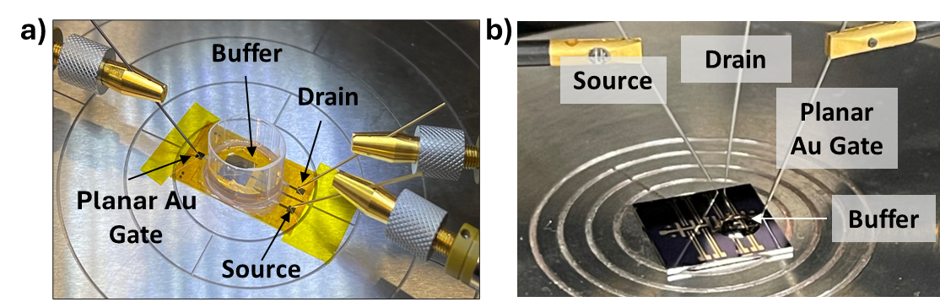
Figure 1. Nanomaterial-based FET biosensors: a) CNT-FET, b) GFET array.

