Boosting the performance of nanoporous graphene-based thin-film microelectrodes for neural interfacing

Elena del Corro
M. Pilar Bernícola, Jose A. Garrido
Catalan Institute of NanoScience and Nanotechnology, ICN2, UAB Campus, 08193 Bellaterra, Barcelona, Spain
elena.delcorro@icn2.cat

Recently, we have demonstrated the superiority of nanoporous graphene-based electrodes as neural interfaces for in vivo recording and stimulation of the central and peripheral nervous system in small animals. [1] We managed to develop a graphene thin film technology based on a large-scale fabrication of flexible microelectrode arrays. Our technology was benchmarked against standard of care revealing higher signal-to-noise ratio than platinum and better charge injection capabilities than iridium oxide. Such superior performance raises from the high capacitance and low sheet resistance of nanoporous graphene electrodes. However, achieving the optimal electrochemical performance of this technology becomes a challenge due to the difficult access of the electrolyte into the nanoconfined space of graphene. By performing a voltage-controlled electrochemical activation of nanoporous graphene electrodes we manage to exploit its electrochemical performance in terms of areal capacitance and electrochemical impedance [2]. The origin of such improvement, of utmost importance for the tailored design of high-performing electrodes based on nanoporous graphene, remains unknown. Advanced operando characterization techniques, like the presented in this work, are needed to reveal the dynamics of the irreversible material changes introduced during the graphene electrochemical activation process, including ionic diffusion and water confinement within the nanopores, along with the reduction of oxygenated groups and the decrease of the graphene interlayer distance. Furthermore, operando techniques are used to uncover the origin of the complex polarization-dependent dynamic response of graphene electrodes.

References
- D. Viana et al., Nature Nanotechnology,19 (2024) 514.
- M. P. Bernícola et al., Advanced Functional Materials 2024, https://doi.org/10.1002/adfm.202408441

Figures
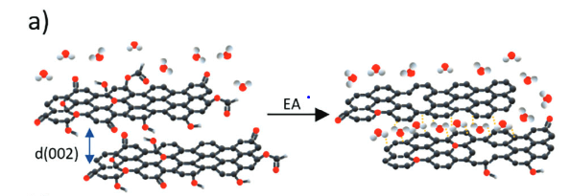
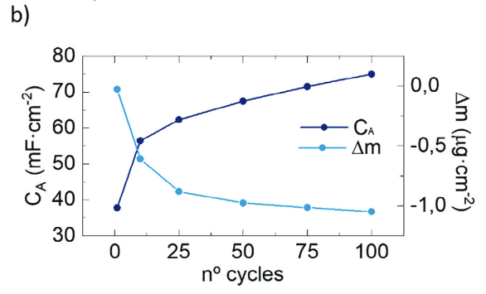

Figure 1: (a) Schematic representation of the effect of electrochemical activation on the graphene morphology. (b) Capacitance (extracted from cyclic voltammetry, CV) and mass change (from quartz crystal microbalance) as a function of the CV cycles.

