**3D-printed microneedle-based electrochemical sensing devices for plant health assessment**

**Marc Parrilla**a

Amadeo Sena-Torralba,a,b Annemarijn Steijlen,a Sergi Morais,b Angel Maquieira,b Karolien De Waela

aA-Sense Lab, University of Antwerp, Groenenborgerlaan 171, 2010, Antwerp, Belgium Instituto Interuniversitario de bInvestigacion de Reconocimiento Molecular y Desarrollo Tecnologico (IDM), Universitat Politecnica de Valencia, Universitat de Valencia, Camino de Vera S/n, 46022, Valencia, Spain

marc.parrillapons@uantwerpen.be

Plant health monitoring is devised as a new concept to unravel real-time physiological processes such as plant stress signaling [1]. The need for an increasing food supply due to an increment in the worldwide population does not match the dramatic effects of climate change, which hinders crop health and increases plant stress. Therefore, plant stress scavengers such as wearable sensors could play a role in controlling crop health and adaptation to new climates [2]. However, affordable sensing devices need to be developed to bring smart sensors into the field. Herein, we propose a technological platform based on a low-cost 3D-printed hollow microneedle array patch (HMA) as a sampling device coupled with biosensors based on screen-printed technology to develop affordable smart sensors for in situ plant analysis [3]. First, an optimization of the 3D-printing method showed for the first time a tip diameter of 25.9±3.7 µm using a 3D printer (<500 EUR) based on stereolithography. Notably, the HMA withstands the forces exerted by thumb pressing (i.e. 20-40 N) needed for a proper insertion. Subsequently, the holes of the HMA enabled up to 15 µl of fluid extraction tested in vivo in plant leaves. Importantly, a paper-based sampling strategy adapted to the HMA allowed the collection of plant fluid in leaves. Finally, integrating the sampling device onto biosensors facilitates the in situ electrochemical analysis of plant health biomarkers (i.e., H2O2, glucose, and pH) and the electrochemical profiling of plants. Overall, the design of the affordable electrochemical platform brings a leap forward in versatile sensors for plant (bio)chemical monitoring, which can accelerate the developments in future precision farming.

**References**

[1] P. Coatsworth, L. Gonzalez-Macia, A.S.P. Collins, T. Bozkurt, F. Güder, Continuous monitoring of chemical signals in plants under stress, Nat. Rev. Chem. 7 (2022) 7–25.

[2] D. Lo Presti, J. Di Tocco, C. Massaroni, S. Cimini, L. De Gara, S. Singh, A. Raucci, G. Manganiello, S.L. Woo, E. Schena, S. Cinti, Current understanding, challenges and perspective on portable systems applied to plant monitoring and precision agriculture, Biosens. Bioelectron. 222 (2023) 115005.

[3] M. Parrilla, A. Sena-Torralba, A. Steijlen, S. Morais, Á. Maquieira, K. De Wael, A 3D-printed hollow microneedle-based electrochemical sensing device for in situ plant health monitoring, Biosens. Bioelectron. 251 (2024) 116131.

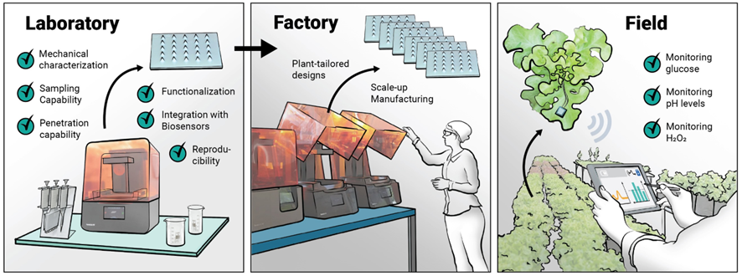

**Figure 1:** From the fabrication of affordable microneedle arrays to the sensing application.