A Nanobiomaterial as Test Membrane for Lateral Flow Assays

Erhan Zor
Ayşe Boyraz, Gökberk Aslan, Sabri Alpaydin
Necmettin Erbakan University, Campus Ahmet Kelesoglu, Konya, Türkiye
ezor@erbakan.edu.tr; zorerhan@gmail.com

Lateral flow biosensors are paper-based devices that allow the detection of different types of analytes with quickness, robustness and selectivity, without leaving behind paper sensors benefits as low-cost, recyclability and sustainability [1]. LFA consists of four basic components: sample pad, conjugation pad, detection pad (nitrocellulose membrane) and waste pad. The nitrocellulose membrane is an important component of the LFA system where signals are generated. The performance of the nitrocellulose membrane directly affects the accuracy and reproducibility of a test result. However, the sensitivity of this type of biosensors is not always as high as required, often not permitting a clear quantification [2]. With the recent advances in nanomaterials, great effort has been devoted to the development of miniaturized analytical platforms [3]. Taking advantage of the nanocellulose, in this talk, the use of bacterial nanocellulose (BNC) as a nanobiomaterial obtained from Acetobacter xylinum culture, exhibiting distinctive properties such as biocompatibility, optical transparency, hydrophilicity, high porosity, and high surface area with hydroxyl-containing groups and high mechanical strength will be overviewed.

References
- Eda Gumus, Haluk Bingol, Erhan Zor, Journal of Pharmaceutical and Biomedical Analysis, 225 (2023) 115206.
- Daniel Quesada-González, Christina Stefani, Israel González, Alfredo de la Escosura-Muñiz, Neus Domingo, Pere Mutjé, Arben Merkoçi, Biosensors and Bioelectronics, 141 (2019)111407.
- Erhan Zor, Talanta, 184 (2018) 149–155

Figures

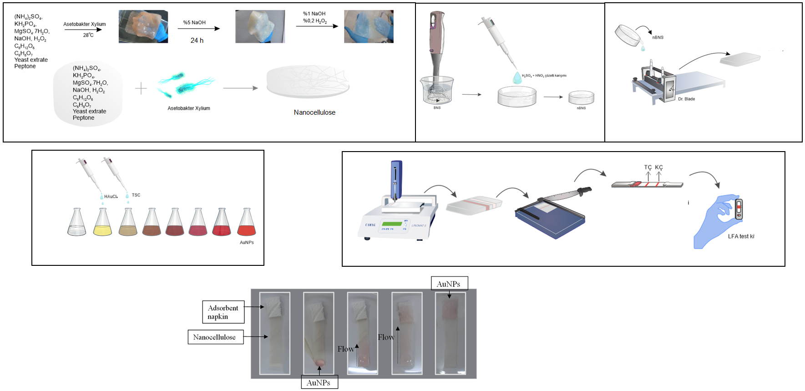

Figure 1: The production process of bacterial nanocellulose-based LFA

Acknowledgements: This study is supported by the Scientific and Technological Research Council of Türkiye (TÜBİTAK), Grant number: 123Z712.

