Single Atom Engineering with Graphene towards Applications in Catalysis, Environmental Technologies and Medicine

Radek Zboril
Czech Advanced Technology and Research Institute (CATRIN), Regional Centre of Advanced Technologies and Materials, Palacký University Olomouc, Šlechtitelů 27, Olomouc, 77900 Czech Republic; Centre for Energy and Environmental Technologies, VSB – Technical University of Ostrava, 17. listopadu 2172/15, 708 00 Ostrava-Poruba, Czech Republic.
radek.zboril@upol.cz

Single atom engineering is an emerging field of materials science allowing to entrap single metal species in suitable supports thus achieving unprecedented properties in various applications including catalysis, energy, medicine or environmental technologies [1,2]. The main challenge lies in the development of suitable reactive supports allowing tunable metal coordination with controllable local environment, valence state and loading of single atoms. Among various supports, the use of pristine graphene is limited due to its chemical stability and restricted possibilities of tailored functionalization for single metal embedding.
Here, we show the unique applicability of well-defined graphene derivatives, graphene acid and cyanographene [3], for the development of advanced single-atom materials. Among catalytic applications, we will report linear structure single-atom gold(I) catalyst for dehydrogenative coupling of organosilanes with alcohols [4], and mixed valence Cu(I)/Cu(II) single atom catalyst for the oxidative coupling of amines and the oxidation of benzylic C-H bonds toward high-value pharmaceutical synthons [5].
The huge potential of single atom engineering in medical technologies will be demonstrated with the development of graphene supported silver- and manganese-based antimicrobial materials overcoming the bacterial resistance [6,7]. Finally, we will show the applicability of graphene acid and single-atom materials in water treatment technologies including heavy metals removal and antibacterial treatment [8].

References
- Kment S. et al., *Chemical Reviews*, 2024, https://doi.org/10.1021/acs.chemrev.4c00155
- Sharma V. K et al., *Chemical Society Reviews*, 52, 7673 (2023).
- Bakandritsos et al., *ACS Nano*, 11, 2982 (2017).
- Kadam R. et al., *ACS Catalysis* 13, 16067 (2024).
- Bakandritsos A. et al., *Advanced Materials*, 31, 1900323 (2019).
- Panáček D. et al., *Advanced Science*, 8, 2003090 (2021).
- Panáček D. et al., *Advanced Materials*, 2024, https://doi.org/10.1002/adma.202410652
- Kolarik J. et al. *ACS Nano*, 15, 3349 (2021).



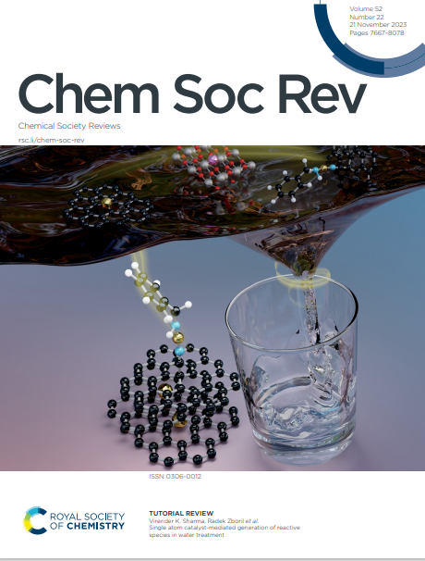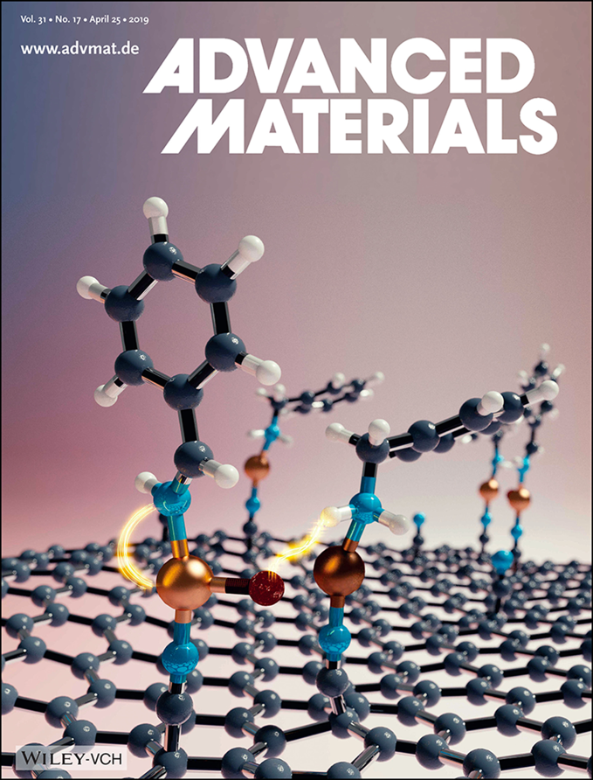
Figure 1. Representative cover arts of publications demonstrating the use of single atom materials in environmental technologies [2], catalysis [5] and medicine [6].

