**Development of Lipid-Based Mucoadhesive Drug Delivery Systems by Thiolation of Non-Ionic Surfactants**

**Presenting Author: Xhoi Xibria**

Co-authors: Giuseppe Francesco Racanielloa, Ilaria Arduinoa, Valentino Laquintanaa, Angela Assunta Lopedotaa, Nunzio Denoraa

aDepartment of Pharmacy – Pharmaceutical Sciences, University of Bari “Aldo Moro”, Italy

[xhoi.xibri@uniba.it](mailto:xhoi.xibri@uniba.it)

**Abstract**

Drug administration via mucosal membranes is preferred over other routes, due to higher patient compliance and acceptance. To address challenges like poor drug solubility and low bioavailability, lipid-based formulations such as self-emulsifying drug delivery systems (SEDDS) and nanostructured lipid carriers (NLCs) have been developed. Among these, SEDDS stand out for their ease of production and scalability in manufacturing [1]. Furthermore, in comparison to solid lipid nanoparticles, liquid lipid inside NLCs improves the loading capacity for drugs and causes a stable incorporation of them inside the carrier [2]. A potential approach to address the short residence time in the GIT is to functionalize the surface of these nanocarriers with thiol groups, thereby enhancing their mucoadhesive properties [3]. One common method to prepare thiolated nanocarriers is the coating of already formed nanocarriers with thiolated excipients [4]. This study aimed to enhance the benefits of PEGylated nanocarriers by developing SEDDS and NLCs containing thiolated PEGylated surfactants, designed to create nanocarriers with strong mucoadhesive properties. To achieve this, surfactants with both short and long PEG chains (Fig. 1) were selected because the length of the PEG chain can impact its conformation and its behavior in biological systems. Polyoxyethylene (10) stearyl ether and polyoxyethylene (100) stearyl ether were thiolated for the first time by substituting the terminal hydroxyl group with a thiol group. The thiolated surfactants were characterized by FT-IR, NMR and Ellman’s test. All nanocarriers had a size <250 nm, a maximum PDI of 0.3 and a ζ potential < -9.0 mV. The mucoadhesive properties and increase in viscosity of SEDDS and NLCs ranked: PSE100-OH < PSE10-OH < PSE100-SH < PSE10-SH. All formulations of these drug delivery systems have been tested in mucosal permeability models, developed in our laboratory. The short chain PSE10-SH showed higher mucus interactions than the long chain PSE100-SH for both SEDDS and NLCs.

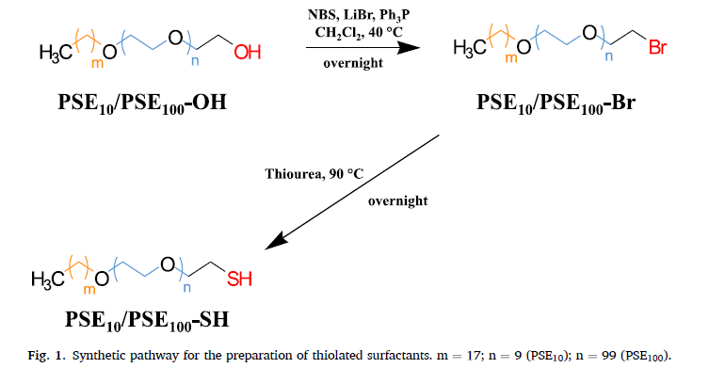

**Figure 1.** Synthetic pathway for the preparation of thiolated surfactants

**References**

**[1]** A. Mahmood, A. Bernkop-Schnürch, SEDDS: A game changing approach for the oral administration of hydrophilic macromolecular drugs, Adv. Drug Deliv. Rev. 142 (2019) 91–101

**[2]** T. Andreani, A.S. Macedo, J.F. Fangueiro, M.H.A. Santana, M. Silva, E.B. Souto, Current State-of-Art and New Trends on Lipid Nanoparticles (SLN and NLC) for Oral Drug Delivery, 2012 (2012)

**[3]** N. Hock, G.F. Racaniello, S. Aspinall, N. Denora, V. V Khutoryanskiy, A. Bernkop-Schnürch, Thiolated Nanoparticles for Biomedical Applications: Mimicking the Workhorses of Our Body, Adv. Sci. (Weinheim, Baden-Wurttemberg, Ger. 9 (2022)

**[4]** M. Greindl, A. Bernkop-Schnürch, Development of a novel method for the preparation of thiolated polyacrylic acid nanoparticles, Pharm. Res. 23 (2006) 2183–2189