How to make an electrochemical aptasensor based on laser-induced graphene electrodes for Escherichia coli detection

Federico MariaVivaldi
University of Pisa, Italy
federico.vivaldi@unipi.it

The detection and identification of pathogenic microorganisms is of crucial importance as they pose a major threat to worldwide health system as well as an economic burden. In this context, biosensors represent a valuable alternative to classical methodologies due to their intrinsic low-cost, short response time, and portability. In this tutorial I’ll present the workflow necessary to develop an aptasensor based on laser-induced graphene (LIG). The fabrication procedure will be shown (Fig. 1A), followed by functionalization protocol for the correct use of aptamers. Finally, the calibration with E.coli will be presented and discussed (Fig 1B). In each section the main challenges will be highlighted, and the necessary steps to move forward will be shown. This lesson will present the fundamental concepts behind LIG based sensors to develop low-cost and portable electrochemical devices that can respond to point-of-care applications.
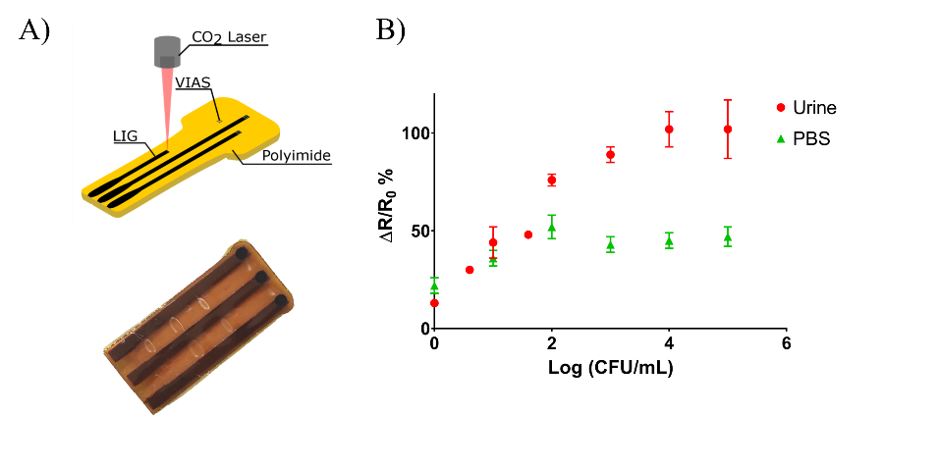
Figure 1: A) LIG electrodes scribed on polyimide. B) Calibration curves at increasing concentration of E. coli in phosphate buffer saline and in urine.
References:
- Vivaldi F., Dallinger A., Bonini A., Poma, N., Sembranti L., Biagini D., Salvo P., Greco F., Di Francesco F., ACS Applied Materials and Interfaces 13 (2021) 30245–30260.
- Marton S., Cleto F., Krieger M.A., Cardoso J., PLoS ONE. 11 (2016) e0153637.

