Some aspects of study the acid corrosion of Portland cement produced in Albania

Sidorela Vishkulli^{1,2}
Maria Hoxhaj^{1,2}, Sonila Vito^{1,2}, Ilirjana Boci^{1,2}, Arjola Pashaj¹
¹Department of Industrial Chemistry, Faculty of Natural Sciences,University of Tirana, Bulevardi “Zogu I”, Tirana, Albania
²Albanian Unit of Nanoscience and Nanotechnology (NanoAlb), Academy of Sciences, Sheshi “Fan Noli”, Tirana, Albania
sidorela.vishkulli@fshn.edu.al

Abstract

Durability is an important engineering property of cement and concrete, which determines their service life. Their mechanical and physical properties may be lost due to interactions with external factors. Among different threatening factors, such as mechanical fatigue, freeze/thaw cycles, thermal stresses, chemical attack may also deteriorate the cement and concrete. Acid attack is particularly detrimental for cementitious material due to its alkaline matrix. This paper focuses on studying the durability of cement pastes from locally produced cement to ascertain their durability to withstand acidic environment degradation. Mass loss and porosity were measured after different times in aggressive solutions with different concentrations. It was concluded that the action of acid attack is dependent on the type of acid, acid concentration, w/c ratio and exposure time. The degradation was significant in long periods of contact time and higher concentrations of acid. Immersion in sulphuric acid leads to stronger attack for the studied samples.

References
- Ali Allahverdi, František Škvára, Ceramics – Silikáty: (2000), 44(3), 114-120.
- Wenjing Zhao, Zirui Fan, Xin Li, Lijuan Kong, Liying Zhang, Materials: (2022), 15(4): 1527
- Vladimir Pavlik, IOP Conf. series: Materials Science and Engineering 549: (2019) 012020
- Sara Irico, Laurence de Meyst, Dirk Qvaeschning, Maria Cruz Alonso, Kristina Villar, Nele de Belie, Materials (Basel): (2020), 13(6): 1431
- Silvia Izquierdo, Erich Rodríguez, Ruby Mejía de Gutiérrez, Revista Ingeniería de Construcción, (2015): 30(3), 169-176
- Shweta Goyal, Maneek Kumar, Darshan Singh Sidhu, Bishwajit Bhattacharjee, Journal of Advanced Concrete Technology: (2009), 7(2), 273-283
- S. Türkel, B. Felekoğlu, S. Dulluç, Sädhanä: (2007), 32(6), 683-691
- Lei Zhang, Linhua Jiang, Fangfang Zhi, Chunmeng Jiang, Weizhun Jin, Guohui Yang, Materials: (2022), 15(23): 8437
- Luisa Barbieri, Luca Lanzoni, Roberta Marchetti, Simone Iotti, Angelo Marcello Tarantino, Isabella Lancellotti, sustainability: (2024), 16: 2444
- Robin E.Beddoe, Cement and Concrete Research: (2016), 88, 20-35
- Hongguang Min, Zhigang Song, Advances in Materials Science and Engineering, 2018
- Ali Allahverdi, František Škvára, Ceramics – Silikáty, (2000), 44(4), 152-160.

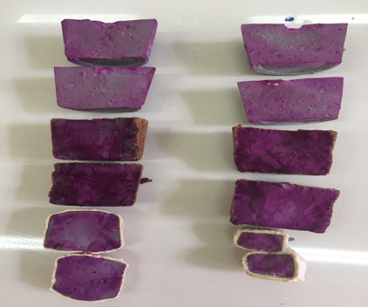
Water
HNO₃
H₂SO₄
Figure 1. Acidic degradation of cement pastes, 3% acid concentration (left) and 5% acid concentration (right)

