Phosphate ions detection by using an electrochemical sensor based on
metal-nanoparicles modified glassy carbon electrode
Nevila Broli^{1,2}
Loreta Vallja^{1,2} , Majlinda Vasjari^{1,2}Sadik Cenolli^{1,2,}Sonila Duka^{1,2}
1Department of Chemistry, Faculty of Natural Science, University of Tirana, Bulevardi Zogu I, 1001 Tirana, Albania
2Nano-Alb, Academy of Sciences of Albania, Fan Noli 7, 1001 Tirana, Albania
nevila.broli@fshn.edu.al

Abstract

Phosphorus has critical values in both agricultural and biomedical applications. Determination of inorganic phosphate is of very high importance in environmental and health care applications.[1] Hence knowledge of suitable analytical techniques available for phosphate sensing for different applications becomes essential.[2] There is a need for highly sensitive, portable, inexpensive, repeatable and field deployable sensors with wide detection range to monitor the health of water and food system.[3,4] This work aims to develop electrochemical phosphate sensor based on metal nanopartices (Au-Np) modified glassy carbon electrodes (GCE) for phosphate detection to achieve simplicity, high sensitivity, wide detection range, and high repeatability and portability. Electrochemical techniques, cyclic voltammetry and square wave voltammetry (SWV) were used to quantify the concentration of phosphate, in NaNO₃ 0.5 mol/L⁻¹ and KCl 0.5 mol/L⁻¹ solution. Experimental parameters affecting the sensitivity of the nanosensors, such as amounts of the modifiers, the pH, the applied potential, and the temperature were optimized. A wide linear response for the detection of the phosphate ion was observed. The response time of the biosensors was about 5 s and maximum relative standard deviation (RSD) of around 5% confirms the repeatability of the proposed sensors.This paper suggests that nanomodified GCE sensors are promising for simple, low-cost, and portable phosphate ion detection.

References
- Md. Aminur Rahman a, Deog-Su Park a, Seung-Cheol Chang b, Calum J. McNeil b, Yoon-Bo Shima. Biosensors and Bioelectronics 21 (2006) 1116–1124
- Md Faisal Kabir†, Md Tawabur Rahman†, Ashim Gurung, and Qiquan Qiao*(2018)DOI 10.1109/JSEN.2018.2808163, IEEE Sensors Journal
- Bernardo Patella a,1,* , Antonino Parisi a,1 , Nadia Moukri a , Federico Gitto a,c , Alessandro Busacca a , Giuseppe Aiello a , Michele Russo b , Alan O’Riordan c , Rosalinda Inguanta. Electrochimica Acta 461 (2023) 142600.
- Stefano Cinti, Daria Talarico, Giuseppe Palleschi, Danila Moscone, Fabiana Arduini*. Analytica Chimica Acta 919 (2016) 78e84
Figures
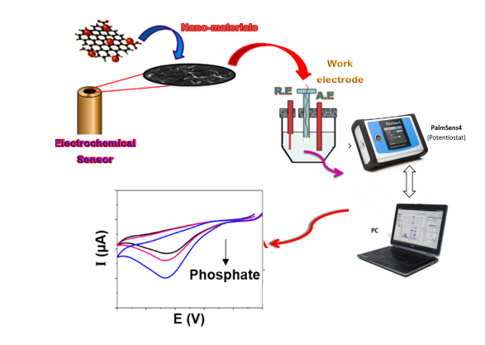

Figure 1: Electrochemical determination of PO4 ³⁻ with modified glassy carbon electrode

