Cost-Effective, Rapid, Fabrication of Nanobiosensors: Consumer Inkjet Printing for Scalable Diagnostics

Massimo Urban¹
Giulio Rosati¹, Arben Merkoçi^{1,2}
¹Catalan Institute of Nanoscience and Nanotechnology (ICN2), Edifici ICN2, Campus UAB, Bellaterra, Barcelona, Spain
²Catalan Institution for Research and Advanced Studies (ICREA), Barcelona, Spain
massimo.urban@icn2.cat, arben.merkoci@icn2.cat

The development of easy-to-implement Point-of-Care (PoC) platforms for electrochemical nanobiosensors has revolutionized fields like environmental diagnostics and healthcare [1]. Between the several techniques and processes, inkjet printing has emerged as a practical, cost-effective method for fabricating biosensors, which can also be done using consumer-grade equipment, making it accessible to virtually any lab [2]. By integrating nanoparticle-based inks, such as gold (Au), silver (Ag) and graphene related materials, this approach allows the rapid production of fully customizable nanosensors without the need for clean-room facilities or expensive machinery.
We show how the workflow, from start to finish, involving design of sensor layouts, inkjet-printing functional materials, and insulation can be performed using simple office-like equipment. The addition of post-processing steps, like sintering/nanostructuration strategies [3], ensure robust, high-performance sensors with high reproducibility. This method not only simplifies the fabrication of electrochemical biosensors, but also supports high-throughput production in a lab setting.
This accessible fabrication pipeline enables the development of platform which can be used as sensitive and selective biosensors tailored to specific applications, paving the way for broader adoption of electrochemical sensing technologies in research labs in a variety of settings.
References
- Stefano, J.S. et al, Current Opinion in Electrochemistry, 32 (2022), 100893
- Rosati, G. et al., Biosens. Bioelectron. 196 (2022), 113737
- Urban, M. et al., Small, 20 (2024), 2306167

Figures

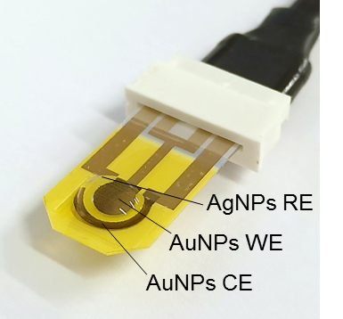

Figure 1: Inkjet-printed electrodes fabricated using office-like equipment and metal nanoparticles based inks

