Cyclodextrin based cross-linked and branched polymers: synthesis and applications

Francesco Trotta
Fabrizio Caldera, Adrian Matencio, Claudio Cecone, Gjylije Hoti
Department of Chemistry, University of Turin, Via Pietro Giuria 7 – 10125 Torino - Italy
Francesco.trotta@unito.it

Nanotechnology stands at the forefront of 21st-century innovation with high applicability of the materials at the nanosize scale in many industrial fields such as electronics and ICT, energy, agriculture, environment and nanomedicine. Cyclodextrin-based polymers (CD-based polymers) are among the most promising nanocarriers that combine biocompatibility with versatility, making them subjects of extensive research and application across various fields. Over time, CD-based polymers have evolved from simple reaction processes to more complex methodologies, reflecting a notable trend towards greener synthesis methods. These nanocarriers exhibit remarkable properties to enhance the solubility, bioavailability, and stabililty of various compounds, making them ideal candidates for drug, protein, gene, natural compounds, and gas delivery. The versatility of CD-based polymers extends beyond healthcare, impacting fields such as chemistry, environment, agriculture, cosmetics, biotechnology, batteries, and additives for the preparation of mixed matrix membranes for gas separation [1, 2, 3]. Various synthetic conditions, organic solvents, water or natural deep eutectic solvents (NADES) are utilized to obtain both crosslinked and branched CD-based polymers. Interesting results were obtained using active carbonyl compounds such as 1,1’-carbonyldiimidazole, diphenyl carbonate, organic dianhydrides, polycarboxylic acid etc., as effective cross-linking agents. The synthesized materials demonstrated excellent safety, stability, biodegradability, biocompatibility, and effective complexing properties. By varying the cross-linking agent or cyclodextrin type, the channels between cyclodextrin molecules can be adjusted, influencing the porous network formation and affecting both complexation and solubilizing ability. This research paves the way to tailor nanocarrier systems with the prospect of increasing their exploitation in countless industrial applications.
References
- [1] Sh. Malik, K. Muhammad, Y. Waheed, Molecules, 28, (2023) 661.
- [2] F. Trotta, M. Zanetti, R. Cavalli, Beilstein J. Org. Chem., 8, (2012) 2091-2099.
- [3] F. Caldera, F. Trotta et al., Int J Pharm, (2017)
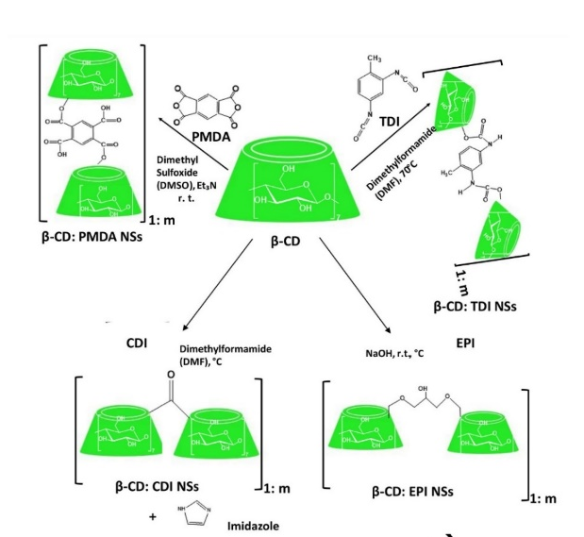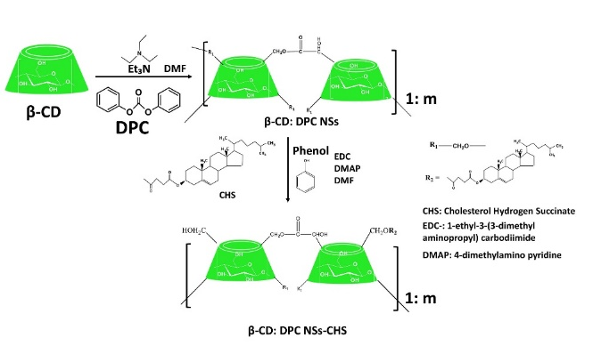

Figure 1: Evolution of CD-based polymer synthesis over successive generations [3].

