An Embedded Electrochemical Sweat Sensor System for Therapeutic Drug Monitoring

A.S.M. Steijlen^{1,2}, R. Nederhoff², J. Bastemeijer², A. Bossche², M. Parrilla Pons¹, K. De Wael¹
¹A-Sense Lab, University of Antwerp, Groenenborgerlaan 171, 2020 Antwerp, Belgium
²Electronic Instrumentation, Delft University of Technology, Mekelweg 4, 2628 CD Delft, The Netherlands
Annemarijn.steijlen@uantwerpen.be
Therapeutic drug monitoring (TDM) optimizes drug efficacy and minimizes adverse effects by precisely measuring drug concentrations in the bloodstream [1]. In this research we investigate wearable electrochemical analysis of sweat for TDM, as a non-invasive and automated alternative for blood analysis. Sweat is a challenging matrix because there are large inter- and intraindividual variations in sweat rate, and sweat composition. Na⁺ and Cl⁻ highly vary with sweat rate (typically 10 to 90 mM) [2] and sweat pH values reported in literature are between 2.1 and 8.2 [3]. Although many electrochemical sweat sensors for continuous monitoring have been developed recently, very few studies take these varying parameters of the matrix into account [4], while they significantly influence the electrochemical measurements of the target molecules.
In this work, we present a smart electrochemical sweat sensor system (electronics and sensors developed in-house) that can perform voltammetric measurements, while also detecting matrix properties: pH, temperature and conductivity. As a first use case we selected high-dose methrotrexate (MTX) therapy to treat cancer, which is the most accepted utility of TDM in oncology [5]. The electroactive compound MTX can be quantitatively detected with square wave voltammetry. The electronics design of the new sweat sensor platform enables to perform this voltammetric measurement using screen-printed carbon electrodes and a Ag/AgCl pseudo reference electrode (figure 1a nr.1). A potentiometric read-out circuit was designed for the pH sensor that uses a carbon working electrode with a polyaniline membrane and a similar reference electrode (figure 1a nr.2). Conductivity electrodes (figure 1a nr.3) and a temperature sensor (figure 1a nr.4) are integrated as well. In figure 1b, typical MTX fingerprints in phosphate buffer (PBS, pH 7.4) detected with our screen-printed sensors can be found. The sensors can detect MTX at concentration levels of 1 µM. Figure 1c shows a significant change in peak current (0.87-1.27µA) and peak potential (0.77-0.88V) with changing pH, proving the importance of measuring these matrix properties. Currently, chemometrics strategies are being developed to derive the absolute MTX concentration in sweat, while knowing pH, temperature and conductivity and taking into account the effects of interferents such as uric acid in de sweat matrix. In short, we present a new platform that can successfully record the voltammetric fingerprints of the antineoplastic drug MTX while also measuring pH, conductivity and temperature to compensate for changing matrix affect, towards a quantitative sweat analysis platform for TDM.
References
[1] T. Junaid et al. Clinical Pharmacy Education, Practice and Research, 2019, pp. 425-436.
[2] L. B. Baker, Temperature, 2019, pp. 211-259
[3] A. B. Stefaniak and C. J. Harvey, Toxicology in Vitro, 2006, pp. 1265-1283
[4] M. Wang et al., Nature Biomedical Engineering, 2022, pp. 1225–1235.
[5] A. Paci et al., European Journal of Cancer, 2014, pp. 2010-2019.
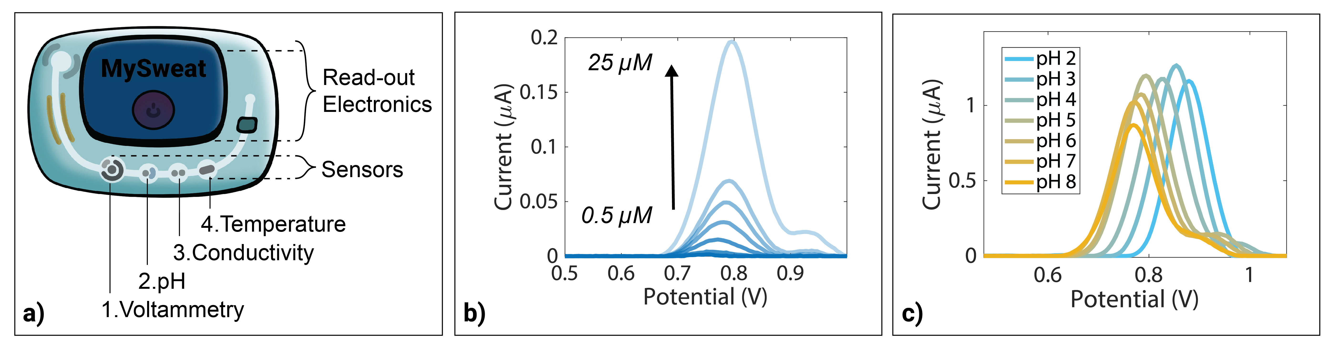
Figure 1: a) Electrochemical sweat platform design. b) Baseline corrected voltammograms of 0.5-25 µM MTX in PBS 7.4 c) pH study of 100 µM MTX with Britton Robinson buffer solutions.

