**Kinetics of bromophenol blue oxidation on carbon felt anode and anode induced graphene oxide nanoparticles**

**Flamur Sopaja,b**

Xhylsime Krasniqia

*aDepartment of Chemistry, Faculty of Natural and Mathematical Sciences, University of Prishtina, st. George Bush, 10000 Prishtina, Republic of Kosovo*

*bAcademy of Science of Albania, Unit of Albanian Nano-science and Nanotechnology - NanoAlb 1000 Tirana, Albania*

flamur.sopaj@uni-pr.edu

Abstract

Electrochemical oxidation of organic pollutants is a very effective method for polluted water treatment. It is based on the electron transfer from the pollutant molecule to the anode, and mostly on the pollutant oxidation by oxidant species generated on the anode and the cathode, such as •OH, H2O2, and S2O82- [1,2]. Carbon felt (CF) is widely used as a cathode contaminated water treatment, but its use as an anode is less explored [1,3,4]. Bromophenol blue (BPHB) was oxidized in an electrolytic cell with CF as both anode and cathode, and Na2SO4 as supporting electrolyte, at various current intensities and supporting electrolyte concentration. During the electrolysis, graphene oxide nanoparticles were generated from the anode, which also are expected to be involved in the oxidation and adsorption of BPHB. At the beginning of the electrolysis, a small increase in the cell voltage was observed, then it reached a plateau or decreased slightly. The concentration of the BPHB during the electrolysis was monitored by UV-Vis spectrophotometry. The oxidative degradation of BPHB was very quick and the rate of degradation increased with lowering Na2SO4 concentration and increasing current intensity.

**Keywords**: Carbon felt, nanoparticles, electrochemical oxidation, bromophenol blue.

**References**

[1] F. Sopaj, M.A. Rodrigo, N. Oturan, F.I. Podvorica, J. Pinson, M.A. Oturan, Chem. Eng. J. 262 (2015) 286–294. https://doi.org/10.1016/j.cej.2014.09.100.

[2] H. Afanga, H. Zaou, F.E. Titchou, J. El Gaayda, F. Sopaj, R.A. Akbour, M. Hamdani, , J. Environ. Chem. Eng. 9 (2021) 104498. https://doi.org/10.1016/j.jece.2020.104498.

[3] F. Sopaj, F. Loshaj, A. Contini, E. Mehmeti, A. Veseli, Results Chem. 6 (2023) 101123. https://doi.org/10.1016/j.rechem.2023.101123.

[4] A. Veseli, Ľ. Švorc, F. Sopaj, Electroanalysis. 33 (2021) 2196–2203. https://doi.org/10.1002/elan.202100183.

**Figures**

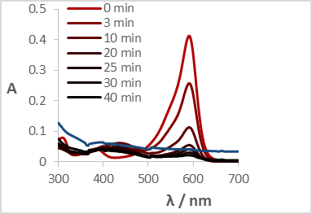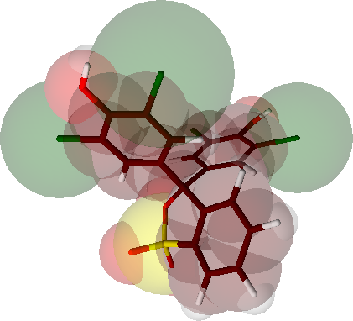

**Figure 1:** UV-Vis spectrum evolution during BPHB oxidation in a CF/CF electrolytic cell. [BHPB] = 0.01 mM, i = 25 mA, [Na2SO4] = 1 mM.