Xenes – monoelemental 2D materials, their synthesis and applications

Zdenek Sofer
Dept. of Inorganic Chemistry, University of Chemistry and Technology Prague, Technicka 5, 166 28 Prague 6, Czechia
Zdenek.sofer@vscht.cz

The Xenes are rapidly developing family of monoelemental 2D materials. The chemistry of graphene as well as other monoelemental materials from group of tetrels and pnictogens will be shown in detail describing various strategies for its synthesis and chemical exfoliation. The differences between the exfoliation of pnictogens and tetrels will be described using chemical and mechanical exfoliation methods. [1] In addition, the methods for the synthesis of all main group of 2D compounds and techniques of crystal growth will be presented.
References
- Hartman, T.; Šturala, J.; Luxa, J.; Sofer, Z., ACS Nano, 14 (2020) 7319

Figures
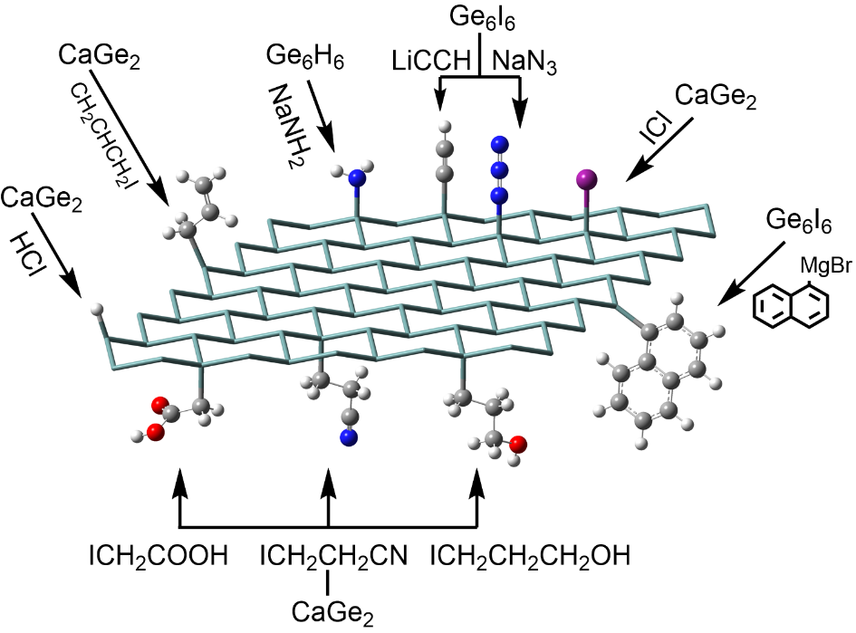

Figure 1: The possible functionalization methods for 2D silicon and germanium.

