A new approach in drug delivery applications: Cryogel microneedles

Emre Ece¹
İsmail Eş¹
Fatih Inci^{1,2}
Yeşeren Saylan³
¹ Bilkent University, UNAM-National Nanotechnology Research Center, Ankara, Turkey
² Bilkent University, Institute of Materials Science and Nanotechnology, Ankara, Turkey
³ Hacettepe University, Department of Chemistry, Ankara, Turkey
yeseren@hacettepe.edu.tr

Microneedles are micron-sized arrays arranged systematically on a small patch. They have gained prominence as a versatile technological tool with numerous applications in delivery and sensing systems, attracting increasing attention¹. Microneedle-based drug delivery is an innovative technology that delivers drug compounds directly into the bloodstream through micron-sized needles². Supermacroporous gels, known as cryogels, are unique scaffolds produced by polymerizing a monomer solution at sub-zero temperatures. These gels are widely used in various applications and have significant potential as biomaterials due to their naturally interconnected supermacroporous structures and the ease of forming composite polymers, making them superior to other porous polymer synthesis techniques³. A microneedle patch is produced using various materials, such as titanium, steel, silicon, and poly dimethylsiloxane (PDMS), through techniques like electric discharge machining, dry/wet etching, or a combination of photolithography and soft lithography. The fabricated patch is characterized by surface area measurements using the Brunauer–Emmett–Teller (BET) method, chemical composition analysis through Fourier-transform infrared (FT-IR) spectroscopy, surface morphology examination with a scanning electron microscope (SEM), 3D laser scanning microscope (Keyence VK-X100), and atomic force microscope (AFM), as well as mechanical strength assessment using dynamic mechanical analysis (DMA). A cryogel microneedle patch is produced through free radical polymerization for use as a drug delivery system. After the thawing process, the cryogel microneedle patch also undergoes characterization using SEM, FT-IR, BET, swelling tests, and gelation efficiency evaluation to determine its chemical and physical structure.

References
- Ece, E., Eş, I., Inci, F. Materials Today. 2023, 68, 275-297.
- Eş, I., Kafadenk, A., Gormus, M. B., Inci, F. Small. 2023, 2206510.
- Saylan, Y., Denizli, A. Gels. 2019, 5(2), 20.

Figures
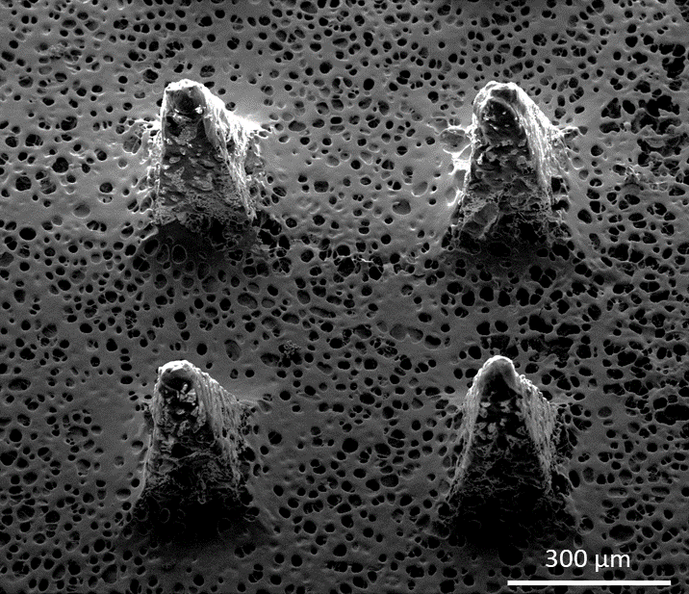

Figure 1: SEM analysis of cryogel microneedles.

Acknowledgement: All authors gratefully acknowledge the support from Health Institutes of Türkiye (TÜSEB) (Project Numbers: 16726).

