Atomically precise porous graphene nanoarchitectures: from synthesis to devices

Aitor Mugarza
Catalan Institute of Nanoscience and Nanotechnology (ICN2), CSIC and The BIST, 08193 Barcelona, Spain
ICREA− Institució Catalana de Recerca i Estudis Avanç cats, 08010 Barcelona, Spain
aitor.mugarza@icn2.cat

Bottom-up nanoarchitectonics has shown remarkable capability in designing nanomaterials with atomic precision. A notable demonstration of this concept is the surface-assisted synthesis of graphene-based nanostructures, where structural parameters are basically designed à la carte. However, despite significant progress in synthesizing one-dimensional homostructures, advancing towards greater structural and compositional complexity presents significant challenges. In this presentation, I will discuss different strategies that we have developed to synthesize porous graphene nanoarchitectures. All are based in a sequential method where we first grow 1D building blocks (nanoribbons), to subsequently coupled them laterally [1]. This sequential method allows us to tune the atomic structure [2] and chemical composition [3] of the pores, with the possibility to realize nanoarchitectures that can be simultaneously conceived as porous membranes and ultranarrow lateral heterostructure superlattices [4].

I’ll start introducing the synthesis and atomic scale characterization of different type of porous nanoarchitectures, and conclude presenting our progress towards the transfer of the nanoarchitectures onto insulating substrates in order to measure properties without the influence of the metallic substrate, and more importantly, fabricate devices.

References
- C. Moreno et al., Science 360 (2018) 199–203.
- C. Moreno et al., J. Am. Chem. Soc. 145 (2023), 8988–8995.
- M. Tenorio et al., Small Methods 2300768 (2023)
- M. Tenorio et al., Adv. Mater. (2022) 2110099.

Figures

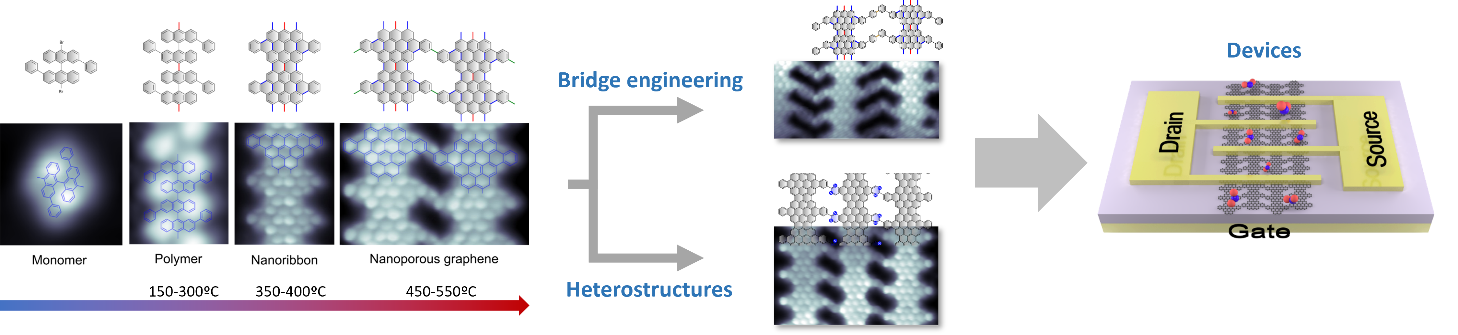

Figure 1: Synthetic route for different porous graphene nanoarchitectures, and schematics of a field-effect transistor gas sensor fabricated with the nanoarchitectures.

