A new lateral capture flow immunoassay configuration for the determination of anti-drug antibodies in patients receiving biologic therapy

Robert S. Marks
Frans Kokojka
Ben Gurion University of the Negev, Department of Biotechnology Engineering, Beer-Sheva, Israel
rsmarks@bgu.ac.il

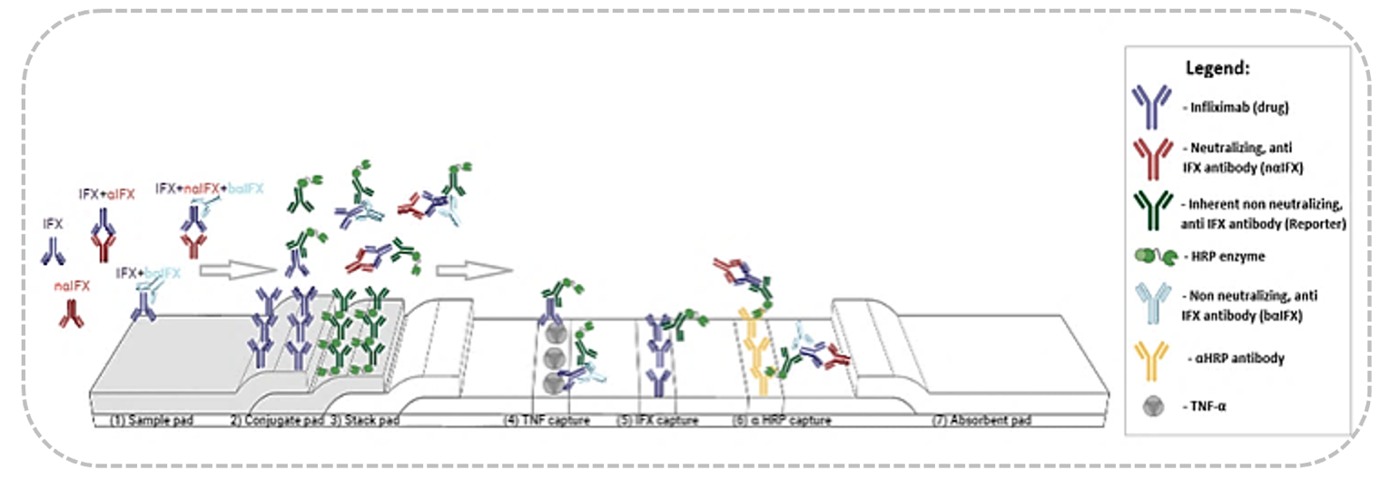
Therapeutic monoclonal antibodies (mAb) are an extensively used category of biological drugs. However, the long-term repeated administration of mAb such as TNF inhibitors elicits immunogenicity which leads to a loss of response (LOR) due to hastened clearance and/or blocking of drug-binding sites mediated by anti-drug antibodies (ADA). Current analytical methods (mainly ELISAs) are inaccurate (drug sensitive) and unsuitable (require long, tedious, lab-based procedures) for routine measurement of drug and anti-drug antibody levels in patients’ circulation, hence they are used only retroactively when patients’ LOR occurs. The proprietary lateral capture flow immunoassay disrupts the current diagnostics workflow by accelerating the time-to treatment, by providing analytical evidence to the presence of neutralizing antibodies and drug levels, lowering misdiagnosis and this, by using a single blood specimen, in less than 20 minutes. Diagnostic uncertainty most often leads to increased observation time and inpatient admission. The treating clinician is faced with a potential dilemma whether to increase the dosage of the biologic drug or to change treatment. Common situations where borderline drug levels are present, and no ADA are detected due to low assay sensitivity cause ambiguity in decision making. Therefore, any advances in diagnostic capabilities would reduce the risks of untimely diagnosis. The intended use of our product is at the attending physicians’ office facing the dilemma of the immunological response in patients as well as time-to-treatment processing. Its clinical utility stems from the intended outcome of a timely detection of drug concentration and neutralizing antibodies enabling a solid-ground-based decision making. By providing a reading of the immunogenicity profile, our capture immunoassay can provide a clear picture about the needed immunotherapy course. Our POCT will increase confidence in whether to increase the dosage of mAb or change therapy for patients as well as monitor the drug level for a more economical treatment. The presentation will cover the utility of our technology, its validation and potential applications for screening different biologics and respective ADAs in clinical settings. This project is in collaboration with the Rambam Health Care Campus and is currently undergoing clinical sample testing.

Figure 1: The new proprietary lateral capture flow immunoassay designed to quantify host-elicited anti-drug neutralizing antibodies and the drug itself, infliximab.

