Beyond Nanoparticles: Advanced Microencapsulation Techniques in Paediatric Pharmaceutical Formulations – A Comprehensive Analysis of the Prilling/Vibration Method and Case Studies
Presenting Author: Lopedota Angela Assunta
Co-Authors : Denora Nunzio, D’Amico Vita, Antonio Lopalco, and Rosa Maria Iacobazzi
University of Bari Aldo Moro, Department Pharmacy Pharmaceutical-Sciences, Via Orabona 4 Bari Italy
angelaassunta.lopedota@uniba.it

Abstract
Microparticles offer a practical and well-established alternative for paediatric drug delivery, particularly when compared to nanoparticle systems. Their larger size inherently reduces the risk of systemic absorption, which minimizes side effects and makes them safer for children.[1] Additionally, microparticles are highly versatile and can be engineered for a range of applications, such as taste masking, colonic delivery, and precise dosage regulation (Figure 1). For instance, they can effectively mask unpleasant medication flavors, which is crucial for improving adherence among young patients. Moreover, microparticles can be tailored to release drugs like anti-inflammatory corticosteroids and probiotics specifically in the colon, enhancing the treatment of gastrointestinal disorders.[2] One of the key advantages of microparticles in paediatric care is their ability to regulate dosage, especially when only adult formulations are available. By engineering microparticles to deliver lower, child-appropriate doses, it is possible to ensure both safety and efficacy in paediatric treatments. This capability is particularly important when adapting adult-formulated drugs for children, allowing for customized treatment that meets the unique needs of paediatric patients without compromising therapeutic outcomes. [3] Among the various techniques for producing microparticles, the prilling/vibration method stands out for its ability to precisely control particle size and morphology. [2] This control is crucial for achieving consistent drug release and optimizing therapeutic outcomes in paediatric applications. Case studies recently published by our group have demonstrated the effectiveness of this method in above citated areas. [3-6] The method’s ability to create uniform microparticles with tailored properties further underscores its value in developing paediatric formulations. In summary, while nanoparticle-based systems have potential, microparticles, particularly those produced via the prilling/vibration method, offer a more reliable and immediately applicable solution for paediatric drug delivery. The proven advantages of microparticles is essential for developing safe, effective, and practical therapeutic options for children.
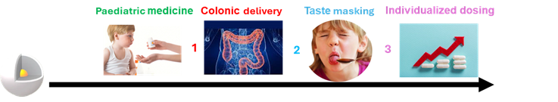
Prilling/vibration
Method
Figure 1: Microparticles produced by the prilling/vibration method meet various needs in paediatric patients.

References.
- Ankita N. Yawalka Journal of Drug Delivery Science and Technology 75 (2022) 103659
- Racaniello G.F. et al. Journal of Pharmaceutical Sciences 113 (2024) 1726−1748
- Ivone M. Journal of drug delivery Science and Technology 99 (2024) 105974
- Lopalco et al. International Journal of Pharmaceutics 574 (2020) 118922
- D'Amico V. et al. Carbohydr Polym. 302: 2 (2023) 12042
- D’Amico V. et al. International Journal of Pharmaceutics 658(2024) 124223

