Role of elastin nanogel-encapsulated Decursin for Prostate Cancer therapy

Vinoth Kumar Lakshmanan
Sri Ramachandra Institute of Higher Education and Research (SRIHER), Chennai, India
vinoth.lakshmanan@sriramachandra.edu.in

Abstract

Prostate cancer (PC) is the most common cancer affecting men and the third leading cause of cancer death. Despite recent advances in detection and localized curative treatment for prostate cancer, 23-40% of those patients will go on to develop metastatic disease. Castration-Resistant Prostate Cancer (CRPC) arises when hormone –refractory growth occurs in a castrate androgen level environment. The androgen receptor (AR) has emerged as important target for therapy for metastatic prostate cancer. Current management of CRPC approved drugs includes Enzalutamide, Docetaxel, Abiraterone acetate and Cabazitaxel. Most of the medications given oral results in low bioavailability, low aqueous solubility, poor permeability, rapid clearance, drug resistance and low concentration at the absorption surface. In view of this limitation, we developed an injectable elastin nanogels for efficient drug delivery system to overcome CRPC is enabling survival benefit and prevention via targeted pathway specific therapies. Unique advantages of our elastin nanogels is a natural protein biopolymers which has a potential application for biomedical purpose with biocompatibility, bioactivity, and is non-toxic, non inflammatory, and non immunogenicity which can be exploited in various drug delivery which longer circulation times and a better chances of targeting the tumor site and may increase passive accumulations expected to be low cost injectable drug delivery system and better than DC beads is a drug delivery embolisation system that used to load anticancer drugs.

References
Rather GA, Selvakumar P, Srinivas KS, Natarajan K, Kaushik A, Rajan P, Lee SR, Sing WL, Alkhamees M, Lian S, Holley M, Do Jung Y, Lakshmanan VK. Facile synthesis of elastin nanogels encapsulated decursin for castrated resistance prostate cancer therapy. Sci Rep. 2024 Jul 2;14(1):15095
Figures

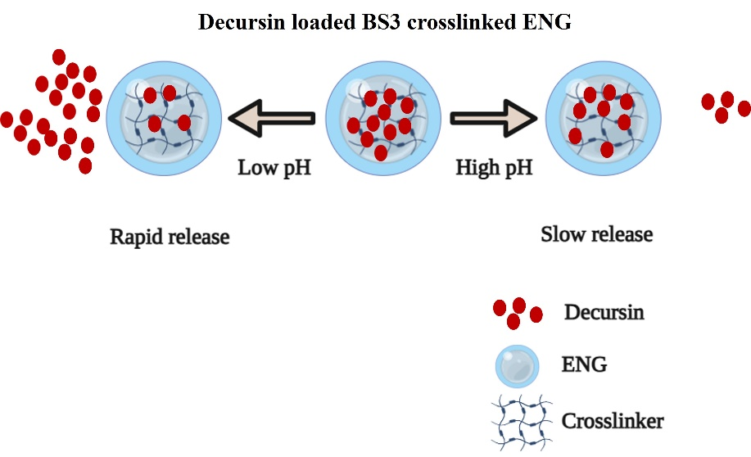

Figure 1: Shows the release of DEC from ENG in response to change in pH. (This image created using biorender.com)

