Multiparameter Monitoring of Oral Health Biomarkers Using Integrated Flexible Sensors

Stephanie Klinghammer¹
Leif Riemenschneider¹, Torsten Sterzenbach², Gylxhane Kastrati¹, Fatima Ahmad¹, Kawah Wong¹, Christian Hannig², Gianaurelio Cuniberti¹
¹ Institute for Materials Science and Max Bergmann Center for Biomaterials, TU Dresden, 01069 Dresden, Germany;
² Clinic of Operative and Pediatric Dentistry and Periodontology, Medical Faculty Carl Gustav Carus, Dresden University of Technology, Fetscherstraße 74, 01307 Dresden, Germany
Stephanie.klinghammer@tu-dresden.de

Maintaining optimal oral health relies on a comprehensive understanding of the intricate bio-adhesive, bio-mineralization, and metabolic processes occurring within the oral cavity. These processes are significantly influenced by the complex composition of oral fluids, particularly saliva and its resident microbiome. [1],[2] However, traditional methods struggle to capture the dynamic fluctuations and heterogeneous variations in oral biomarkers. [3],[4]
This paper presents a novel approach for continuous, real-time monitoring of multiple oral health biomarkers using integrated flexible sensors embedded within a personalized dental splint. The device incorporates electrochemical and open circuit potentiometry sensors to measure key parameters such as glucose, pH, lactate, calcium, phosphate, and fluoride concentrations in saliva, alongside monitoring real-time biofilm formation.
As an example, the pH measurements are presented. The pH sensors exhibited a linear response of -53.8 mV/pH in buffer tests. Unstimulated saliva samples from different volunteers were measured, and the pH values matched closely with those obtained using a commercial pH electrode. Potentiometric measurements were also conducted for calcium and fluoride ions.
Continuous glucose and lactate monitoring was achieved amperometrically, demonstrating the platform's potential for real-time tracking of key metabolic markers.
This multi-sensor platform offers a promising avenue for early detection of oral diseases, personalized treatment strategies, and improved patient outcomes.

References
[1] C. Hannig, M. Hannig, A. Kensche, and G. Carpenter, Arch Oral Biol, vol. 80, pp. 144–152, Aug. 2017,
[2] T. Sterzenbach, R. Helbig, C. Hannig, and M. Hannig, Clin Oral Investig, vol. 24, no. 12, pp. 4237–4260, Dec. 2020
[3] C. G. J. Schabmueller, D. Loppow, G. Piechotta, B. Schütze, J. Albers, and R. Hintsche, Biosens Bioelectron, vol. 21, no. 9, pp. 1770–1776, Mar. 2006
[4] J. Timpel et al., Clin Oral Invest, vol. 27, no. 10, pp. 5719–5736, Sep. 2023

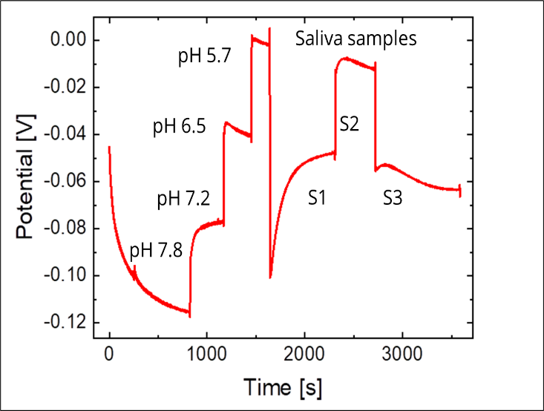
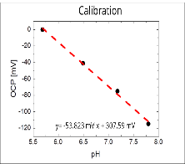
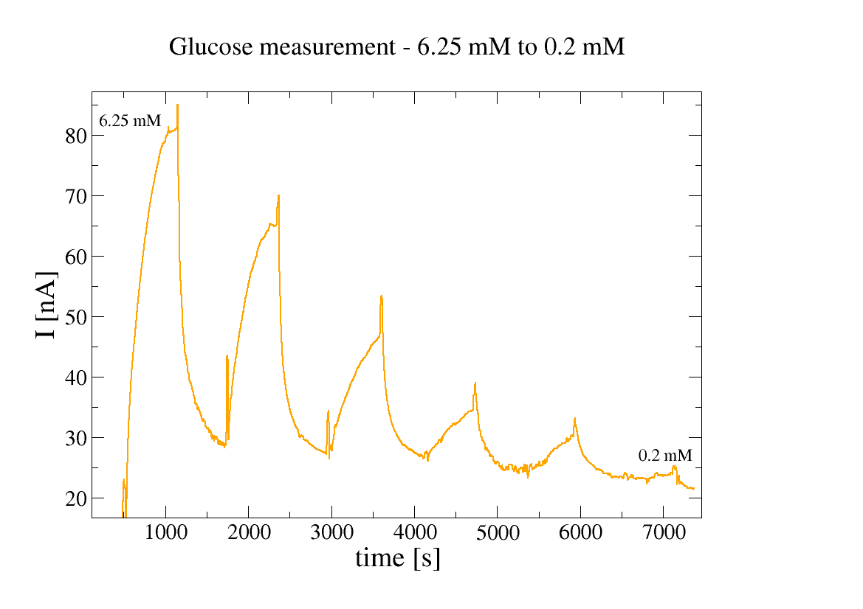
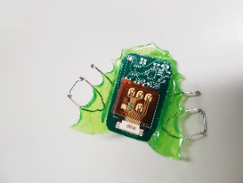
Figures
Figure 1: a) Device for continuous monitoring of health parameters within the oral cavity. b) Potentiometric measurement of pH. Shown are measurements with phosphate buffers of the indicated pHs and measurements with three different saliva samples. (b) Amperometric response of glucose sensors.

