Navigating Borders: A Young Female Scientist’s Impact in Nanoscience and the Everyday Significance of Polymeric Materials

Gjylije Hoti
Francesco Trotta, Fabrizio Caldera, Roberta Cavalli, Monica Argenziano, Anna Scomparin, Claudio Cecone, Adrián Matencio, Ibrahim Hussein, Sara Er-Rahmani, Ilona Krabicová, Alessio Ballarano

Department of Drug Science and Technology, Department of Chemistry, University of Torino, Via P. Giuria 7 and 9, 10125 Torino, Italy
gjylije.hoti@unito.it

Abstract

Throughout the history of science, women have played a pivotal role in shaping a brighter future through their dedication to science and technology. Despite facing unique challenges, female researchers have made tremendous strides, breaking down barriers and pursuing their passion for discovery. Their resilience has not only advanced scientific knowledge but also inspired future generations, encouraging today’s young girls to become tomorrow’s leading scientists and innovators. My journey has been deeply inspired by these trailblazing women, who have served as beacons of innovation and determination. I left home to study in a foreign country as a young female student, far from my family and support system. I faced numerous personal and professional challenges, knowing no one and navigating a new culture. Yet, I persisted, understanding that embracing change, crossing borders, and connecting with remarkable people and scientists while learning from them would be key to strengthening my personal and professional growth. This challenging but fulfilling journey led me to the world of nanotechnology, a field that has emerged as a powerful tool for addressing global challenges and advancing sustainable development. In recent years, the health industry and academia have increasingly focused on research and innovation to enhance disease prevention and treatment strategies. My scientific work has concentrated on the cost-effective and flexible synthesis of advanced, biocompatible polymeric nanocarriers with the potential to make a significant impact both scientifically and economically. My current research explores the use of nanotechnology-based carriers, such as nanosponges, to cross the Blood-Brain Barrier (BBB). These nanocarriers are designed to enable sustained and controlled drug release, thereby improving the development of new therapeutic treatments [1].
I firmly believe that in any journey, there are no winners or losers—only learners. My dream has always been to contribute to research with a profound impact on both health and the planet. Though the path can be tough and competitive, science knows no borders and the success of our work becomes unstoppable when we, as young scientists, reveal our true potential and contribute with passion, self-belief, motivation, and determination.
References
- Hoti G., Caldera F., Cecone C., Rubin Pedrazzo A., Anceschi A., Appleton S. L., Monfared Y. K., and Trotta F. Materials, 14 (2021) 1-20.
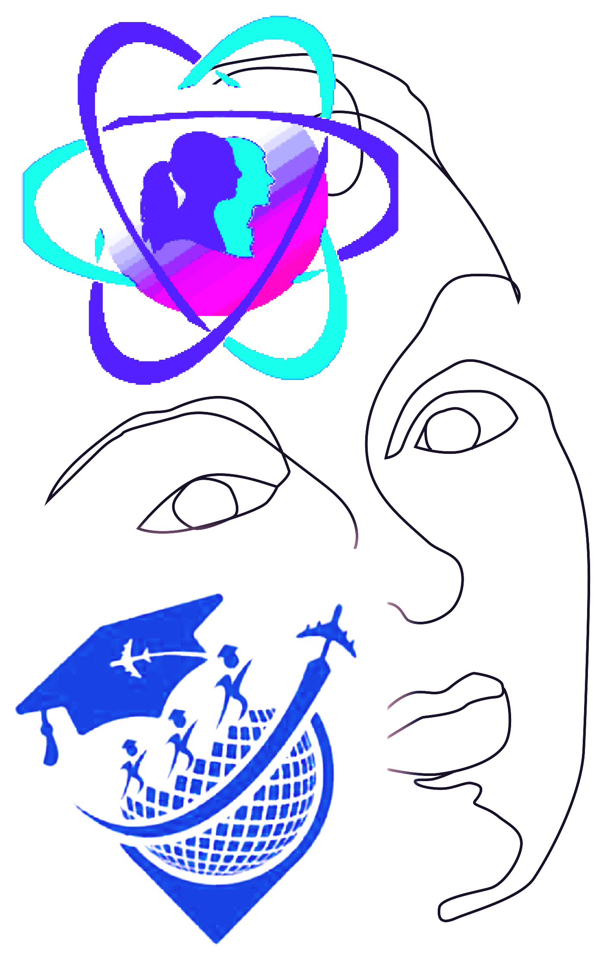
Women in Science

