Integrating nanotechnology with mercuric reductase from bacteria for enhanced mercury bioremediation
Anila Hoda^{1,2},
Mirela Lika (Çekani)³, Valbona Kolaneci¹, Xhelil Koleci¹
¹Agricultural University of Tirana, Albania
²Academy of Sciences of Albania
³University of Tirana
ahoda@ubt.edu.al

Mercury (Hg) pollution is a significant environmental issue due to its toxic effects, persistence, and ability to bioaccumulate in ecosystems, posing serious risks to both human health and wildlife. This study focuses on the mercuric reductase enzyme from the Pseudomonas fluorescens, which is crucial for mercury detoxification. The enzyme reduces toxic mercury ions (Hg^2+) into less harmful elemental mercury (Hg(0)), thus mitigating mercury's harmful impacts. Bioinformatics tools were used to analyze the enzyme’s protein sequence to understand its structural and functional characteristics. Virulence prediction confirmed that the enzyme is non-toxic and non-pathogenic. Further analysis, including homology modeling and docking studies, provided detailed insights into the enzyme's three-dimensional structure and its interactions with mercury substrates. The mercuric reductase enzyme, belonging to the Pyridine nucleotide-disulphide oxidoreductase family, class I, is composed of 548 amino acids and contains crucial functional domains necessary for mercury reduction. Physicochemical analyses revealed that the enzyme is hydrophilic and structurally stable. The predicted three-dimensional model was validated, confirming its accuracy. Evolutionary studies identified conserved regions among homologous sequences, suggesting functional relationships with other mercury-detoxifying proteins. Additionally, protein-protein interaction networks highlighted the enzyme’s collaborative role in mercury detoxification pathways. Docking studies further demonstrated the enzyme’s efficacy in reducing mercury. The study also explores the integration of nanotechnology to enhance the enzyme’s activity and stability. Nanoparticles can serve as carriers, improving enzyme immobilization and facilitating targeted delivery, thereby increasing the efficiency of mercury bioremediation. This innovative approach could significantly boost the effectiveness and sustainability of mercury pollution management strategies. In conclusion, the combination of mercuric reductase from bacteria and nanotechnology represents a promising strategy for the eco-friendly remediation of mercury-contaminated environments. This synergy could provide more effective and sustainable solutions for managing mercury pollution, making it an area of interest for further research to optimize its application in various environmental conditions.

References
- Driscoll, C. T., Mason, R. P., Chan, H. M., Jacob, D. J., & Pirrone, N. (2013). Mercury as a Global Pollutant: Sources, Pathways, and Effects. Environmental Science & Technology, 47(10), 4967–4983. https://doi.org/10.1021/es305071v
- Eltarahony, M., Ibrahim, E., Hegazy, G., & Sabry, A. (2023). Microbial Remediation of Mercury: An Overview. In N. Kumar (Ed.), Mercury Toxicity: Challenges and Solutions (pp. 201–234). Springer Nature. https://doi.org/10.1007/978-981-99-7719-2_8, Journal, Issue (Year) page (Calibri 11) Indicate references with sequential numbers within [square brackets].
- Liu, Y., Grimm, M., Dai, W.-T., Hou, M.-C., Xiao, Z.-X., & Cao, Y. (2020). CB-Dock: A web server for cavity detection-guided protein-ligand blind docking. Acta Pharmacologica Sinica, 41(1), 138–144. https://doi.org/10.1038/s41401-019-0228-6, Journal, Issue (Year) page

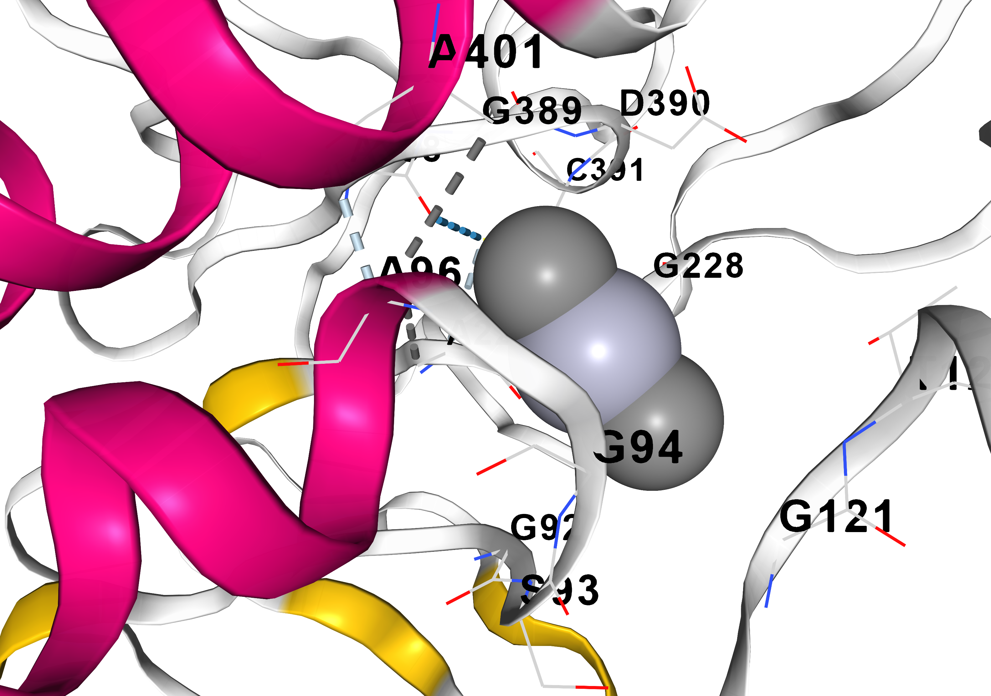

Figure 1: A docked complex of dimethyl mercury with mercuric reductase

