Potential use of PVA modified with MMT in medical masks. Case study: lncorporation of lavender oil in PVA/MMT

Albana Hasimi¹
Partizan Malkaj², Blerina Papajani³, Elvin Çomo¹, Mirela Ndrita¹
1 Institute of Geoscience, Polytechnic University of Tirana, Tirane 1022 Albania
2 Faculty of Mathematical Engineering and Physics Engineering, Polytechnic University of Tirana, Tirane 1024 Albania
3 Faculty of Natural Science, University “A Xhuvani” Elbasan, Albania
albahasimi@gmail.com

Abstract

Polyvinyl alcohol (PVA) is a synthetic polymer that has gained significant attention for biomedical applications due to its unique properties. Here is an overview of its key characteristics and uses in the biomedical field: Biocompatibility, Hydrophilicity, Mechanical Strength and Flexibility, Non-Adhesive, Chemical Modifiability, Cross-Linking Capability [1-3]. Our team suggests the functions of a high-performance face mask in the respiratory pandemic. All this with the aim of more environmentally friendly approaches to coverage in the face of COVID-19 and future pandemics.
In this study our group worked on the possibility of modifying the properties of PVA (polyvinyl alcohol) polymer by adding Montmorillonite [MMT], to produce PVA/MMT matrix nanofibers for biomedical applications and the encapsulation of an essential oil of an Albanian medicinal plant (Lavender) for in vitro testing [3].
Three grades of film were prepared – pure PVA, PVA/MMT and PVA/MMT/lavender oil. After that, the structure, morphology, and properties of all the classes of films produced has characterized [4].
MMT does not change the structure of PVA, as confirmed by thermographs. On the other hand, as shown by the FTIR spectra, MMT is not chemically bonded to the PVA polymer. MMT does not change the physicochemical behavior of the matrix, this results from the water uptake experiments.
As a result, we conclude that MMT makes it possible to use PVA polymer as a mask with aromatic medicinal oil for various medical uses [5].

References
- Dorel Feldman. J. Compos. Sci. 2020, 4, 175; doi:10.3390/jcs4040175
- Nikolaos Chousidis, Eng. Res. Express 6 (2024). doi 10.1088/2631-8695/ad4cb4
- Albana Hasimi, Elvin Çomo, et al. International Journal of Chemical and Materials Engineering Vol:17, No:02, (2023) page 101-104
- A. Hasimi, A. Stavropoulou, K.G. Papadokostaki, M. SanopoulouEuropean Polymer Journal 44 (2008) page 4098–4107
- Marieta Constantin et all. Polymers 2023, 15, 4. doi.org/10.3390/polym15010004

Figures
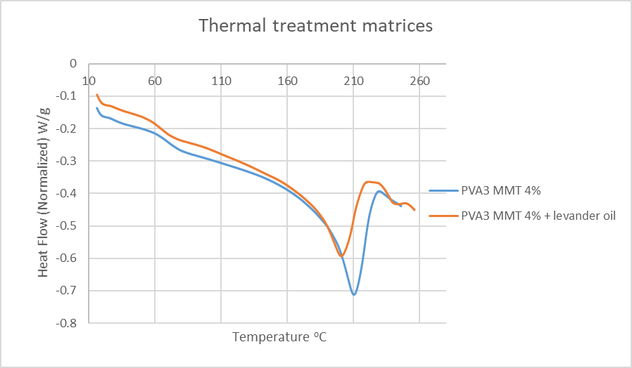 | 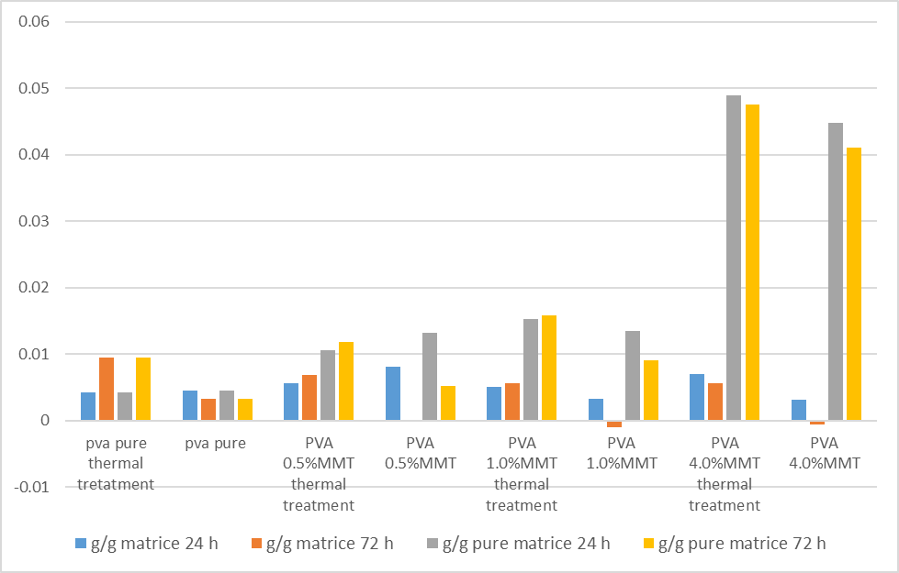
Figure 1: Thermal properties, effect of lavender oil | Figure 2: Αbsorption of lavender oil in all categories of membranes

