Ex Situ Covalent Functionalization of Germanene via 1,3-Dipolar Cycloaddition: A Promising Approach for the Band Gap Engineering of Group 14 Xenes

Presenting Author: Theodosis Giousis
Co-Authors: Panagiota Zygouri, Niki Karouta, Konstantinos Spyrou, Mohammed Subrati, Dimitrios Moschovas, Marc C. A. Stuart, Hamoon Hemmatpour, Dimitrios P. Gournis and Petra Rudolf
Department of Materials Science and Engineering, University of Ioannina, 45110 Ioannina, Greece
Zernike Institute for Advanced Materials, University of Groningen, Nijenborgh 4, 9747 AG Groningen, the Netherlands
Contact@E-mail: t.giousis@uoi.gr
Group-14 Xenes beyond graphene such as silicene, germanene, and stanene have recently gained a lot of attention for their peculiar electronic properties, which can be tuned by covalent functionalization. Up until now, reported methods for the top-down synthesis of covalently functionalized silicene and germanene typically yield multilayered flakes with a minimum thickness of 100 nm. Herein, we report the ex situ covalent functionalization of germanene via 1,3-dipolar cycloaddition of the azomethine ylide generated by the decarboxylative condensation of 3,4-dihydroxybenzaldehyde and sarcosine. Amorphous few-layered sheets (average thickness of ~6 nm) of dipolarophile germanene were produced by thermal dehydrogenation of its fully saturated parent precursor, germanane. Spectroscopic evidence confirmed the emergence of the dipolarophilic sp2 domains due to the dehydrogenation of germanane, and their sp3 hybridization due to the covalent functionalization of germanene. Elemental mapping of the functionalized germanene revealed flakes with a very high abundance of carbon uniformly covering the germanium backbone. The 500 meV increase of the optical band gap of germanene observed upon functionalization paves the way toward band gap engineering of other group-14 Xenes, which could potentially be a major turning point in the fields of electronics, electrocatalysis, and photocatalysis.

References
- T. Giousis, G. Potsi, A. Kouloumpis, K. Spyrou, Y. Georgantas, N. Chalmpes, K. Dimos, M.-K. Antoniou, G. Papavassiliou, A. B. Bourlinos, H. J. Kim, V. K. S. Wadi, S. Alhassan, M. Ahmadi, B. J. Kooi, G. Blake, D. M. Balazs, M. A. Loi, D. Gournis, P. Rudolf, Angew. Chem. Int. Ed. 2021, 60, 360-365
- V. Georgakilas, A. Bourlinos, D. Gournis, T. Tsoufis, C. Trapalis, A. Mateo-Alonso, M. Prato, J. Am. Chem. Soc. 2008, 130, 8733-8740

Figures
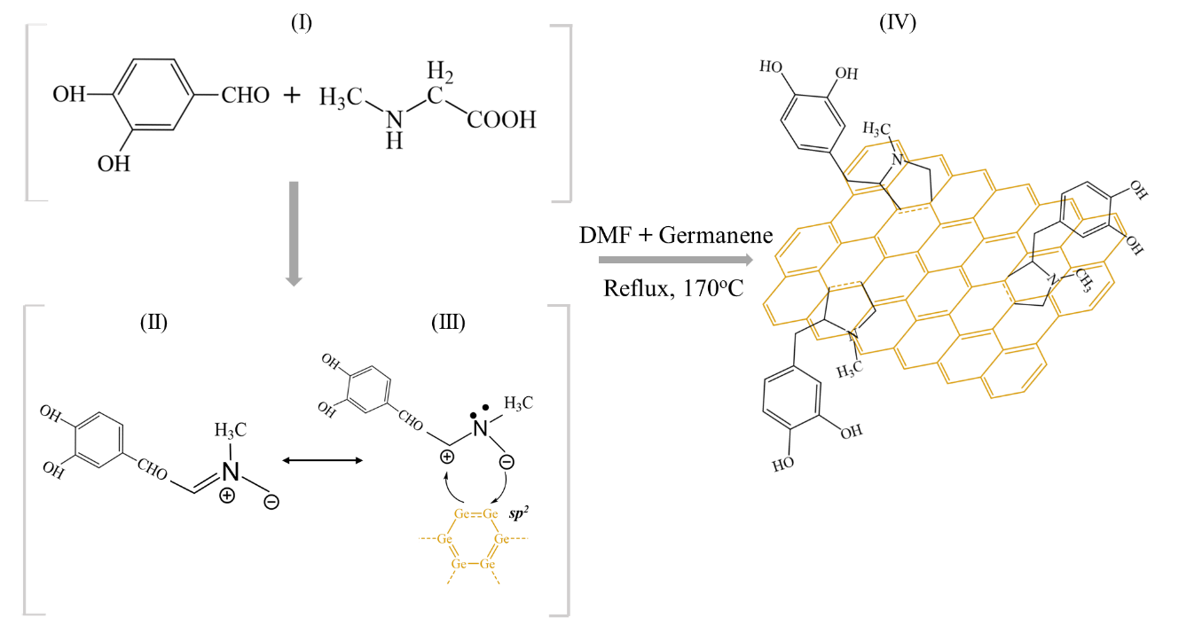

Figure 1: Proposed mechanism of the 1, 3 Dipolar cycloaddition reaction of azomethine ylides to the germanene layers

