CRISPR/Cas toolbox for biosensing applications: from pathogens to non-nucleic acids detection
Angela Gilda Carota
University of Pisa, Italy
angela.carota@phd.unipi.it
The Clustered Regularly Interspaced Short Palindromic Repeat loci (CRISPR) and its associated proteins Cas, collectively known as the CRISPR/Cas system, constitute an adaptive immune system present in Archaea and bacteria to protect the organism from foreign invaders. The activation of the Cas/gRNA complex is triggered by the detection of the target DNA (or RNA) sequence, which is cleaved in specific positions (primary activity), while nonspecific cleavage of ssDNA (or RNA) sequences (collateral activity) could occur depending on the Cas type (Figure 1). During this lecture, the potential of CRISPR/Cas technology in biosensing will be explored highlighting the versatility of the system through some examples reported from the literature: the wide range of analytes and transduction mechanisms will demonstrate how this programmable and specific system emerged as a powerful tool for biosensing and the resulting perspectives in point-of-care applications.
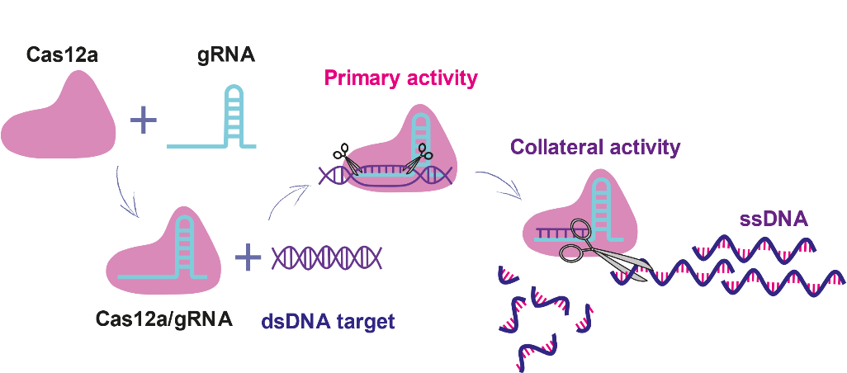
Figure 1. CRISPR/Cas12a system detection mechanism.

References:
[1] A. Bonini, N. Poma, F. Vivaldi, A. Kirchhain, P. Salvo, D. Bottai, A. Tavanti, F. Di Francesco, Journal of pharmaceutical and biomedical analysis, 192, 114268 (2021).
[2] A. G. Carota, A. Bonini, M. Urban, N. Poma, F. M. Vivaldi, A. Tavanti, M. Rossetti, G. Rosati, A. Merkoçi, F. Di Francesco, Biosensors and Bioelectronics, 116340 (2024).

