**Occurrence of microplastics in fishes from aquatic ecosystems of northern Kosovo**

__________________________________________________________________________________

**Andonita Bucinca1,2,3**

Halil Ibrahimi1, Giangiacomo Beretta2,Linda Grapci1, Astrit Bilalli3, Afrim Berisha4,Donika Peja5, Armond Daci6*

*1Department of Biology, University of Prishtina “Hasan Prishtina” Faculty of Mathematics and Natural Sciences, Rr. "George Bush", Nr.31, 10000 Pristina -Kosovo*

*2 Department of Environmental Science and Policy, Universität degli Studi di Milano, Milan, Italy*

*3 Department of Food Technology, University of Peja “Haxhi Zeka”, Faculty of Agribusiness, Pejë, Kosovo*

*4 Kosovo Environmental Protection Agency Luan Haradinaj Street, New Government Building of Kosovo*

*5 Hydrometeorological Institute of Kosovo Rr. Lidhje e Pejës, Nr.47, 10 000 Pristina, Kosovo*

*6 Department of Pharmacy, Faculty of Medicine University of Prishtina, 1000 Prishtina, Kosovo*

[andonita.bucinca@gmail.com](mailto:andonita.bucinca@gmail.com)

Abstract

This study aimed to assess the possible presence of environment contaminant microplastics (MP) in the digestive systems of fish samples captured in the northern region of Kosovo as well as in the corresponding surface waters. Given that fish are consumed by residents, they may represent a potential source of microplastics for humans. The identification of MP was attempted within specimens isolated from *Squalius cephalus*, *Rutilus rutilus*, *Chondrostoma* *nasus*, *Alburnus alburnus*, *Alburnoides bipunctatus*, and *Lepomis gibbosus*. The MP analysis consisted of two steps, *i*.*e*. preliminary evaluation by optical microscopy followed by tentative chemical characterization by Fourier-transform mid-infrared attenuated total reflection spectroscopy (ATR-FTIR) for the investigation of plastics polymers [1]. The results, indicating that microplastics were present in all studied fish species, were in accordance with other studies showing that MP items enter the trophic chain with a potential impact on food security and human health [2]. Information from the statistical evaluation of the spectroscopic data is also presented.

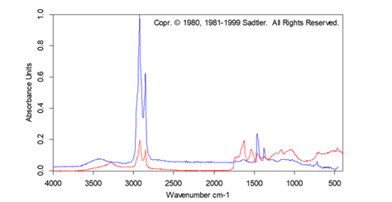

**Figure 1**. Identification of polyethylene in a fish sample of the presented study

**References:**

[1] T. Andreas Hadibarata, P. Sathishkumar, H. Prasetia, E.D. Hikmat Pusfitasari, A.N. Tasfiyati, D. Muzdalifah, J. Waluyo, A. Randy, D.P. Ramadhaningtyas, O. Zuas, A.A. Sari Microplastic contamination in the Skipjack Tuna (Euthynnus affinis) collected from Southern coast of Java, Indonesia Chemosphere, 276 (2021), Article 130185.

[2] Agathe Bour, Carlo Giacomo Avio, Stefania Gorbi , Francesco Regoli, Ketil Hylland. Presence of microplastics in benthic and epibenthic organisms: Influence of habitat, feeding mode and trophic level, [Environmental Pollution](https://www.sciencedirect.com/journal/environmental-pollution) [Volume 243, Part B](https://www.sciencedirect.com/journal/environmental-pollution/vol/243/part/PB), December 2018, Pages 1217-1225.

**nanoBalkan2024** Tirana (Albania)