Reduced graphene oxide decorated with Fe₂O₃ nanoparticles composite carbon paste electrode (CPE) for voltammetric determination of atenolol
Nevila Broli^{1,2}
Ergi Hoxha^{2,3}, Sadik Cenolli^{1,2}, Majlinda Vasjari^{1,2}
1Department of Chemistry, Faculty of Natural Science, University of Tirana, Bulevardi Zogu I, 1001 Tirana, Albania
2Nano-Alb, Academy of Sciences of Albania, Fan Noli 7, 1001 Tirana, Albania
3Western Balkans University, Faculty of Dental Medicine, Department of Basic Sciences,Tirana, Albania.

nevila.broli@fshn.edu.al

Abstract
An effective electrochemical sensing platform for the determination of atenolol (ATN) based upon magnetic nanoparticles Fe₂O₃/reduced graphene oxide (rGO) bulk modified carbon paste electrodes (F₂O₃-rGO/CPE) is reported. The electrochemical studies and measurements were carried out by using voltammetry (CV) and square wave voltammetry (SWV) techniques. The nanocomposite-modified carbon paste electrode (Fe₂O₃-rGO/CPE) exhibited enhanced electrocatalytic performance for the determination of ATN. The proposed method using Fe₂O₃-rGO/CPE sensor is characterized by high sensitivity of measurements, with the linearity of ATN in the range from 40 to 3138 µmol L⁻¹. The lowest detection limit achieved on the Fe₂O₃-rGO/CPE nanocomposite electrode for 10 s of preconcentration time was 58 µmol L⁻¹ ATN in 0.1 mol L⁻¹ H₂SO₄ of pH 2.0 using square wave technique. The nanomodified Fe₂O₃-rGO/CPE sensors showed a good reproducibility and repeatability (RSD ≤ 5%,) for ATN determination. The reduced graphene oxide decorated with magnetic nanoparticles Fe₂O₃₋rGO results with a good enhancement in the sensitivity of the sensor through a combination of increased surface area and improved electron transfer kinetics. Finally, the fabricated Fe₂O₃-rGO/CPE exhibits high sensitivity and good stability towards the sensing ANT and has the potential to be utilized as a clinical assay and quality assurance (QA) in pharmaceutical products.

Keywords: Atenolol, reduced graphene oxide, nanocomposite, modifed glassy carbon electrode, square wave pulse voltammetry ·

References
- Joanna Smajdor¹, Marcel Zambrzycki², Mateusz Marzec³, Beata Paczosa-Bator¹,Robert Piech¹, Microchimica Acta (2023) Volume 190:449
- [1] Broli, N., Vasjari, M, Cenolli, Vallja, L.S. Duka, S, Shehu, A., (2021) , Opean Chemistry-19(1):875-0071
- Mona A Mohamed ¹, Shimaa A Atty ¹, Hanan A Merey ², Taghreed A Fattah ¹, Christopher W Foster ³, Craig E Banks ³, Analyst, Issue 19, (2017) page 3674-3679
- Eagambaram Murugan* and Kalpana Kumar.Analytical Chemistry. Vol 91/Issue 9. (2019)

Figures
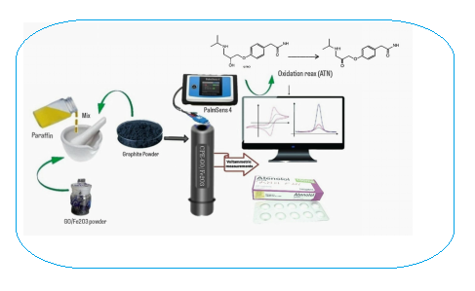

Figure 1: Scematic determination of ATN with Fe₂O₃-rGO/CPE sensor

