Characterization with molecular spectroscopy of 3-[2-(thiazol-2-yl)hydrazinylidene]chroman-2,4-dione
Drenusha Bega
Ahmed Jashari, Naim Mahmudi
-State University of Tetovo, Faculty of Natural Science and Mathematics, 1200 Tetovo, Republic of North Macedonia
-NanoAlb Unit of Nanoscience and Nanotechnology, Academy of Science of Albania, Fan Noli square, Tirana, Albania
d.bega211622@unite.edu.mk

Abstract
In this study, spectroscopic methods were used to analyze the new derivative of coumarin - 3-[2-(thiazol-2-yl)hydrazinylidene]chroman-2,4-dione with a complex organic structure through UV-Vis and IR spectroscopy. UV-Vis measurements were conducted under different pH conditions, ranging from pH=1-12, to observe the impact of pH on the electronic behavior and structure of the substance. In the UV-Vis spectra, a significant shift was observed in the first band (212 nm) in a highly acidic environment (pH=1), suggesting the protonation of the substance. Additionally, (190-210 nm) and (250 nm) electronic transitions related to the substance's structure were identified, focusing on the free electron pairs of heteroatoms such as oxygen and nitrogen. Through the changes in pH, spectral shifts and structural alterations were observed, particularly in basic pH where coumarin structure breakdown and regeneration occurred. In IR spectroscopy, the characteristic vibrations of functional groups such as the OH group (3650-3450 ), aromatic CH groups (3100-3050 ), and the keto group (1750 ) were analyzed. Additionally, benzene deformations and the presence of diazo group (N=N) were observed in the infrared spectrum. This combination of methods helped identify the characteristic groups and determine the structure of the substance, demonstrating the connection between its structure and behavior under different pH conditions.

References
[1] K. C. Nicolaou, Christopher R. H. Hale,a Christian Nilewskia and Heraklidia A. Ioannidoua, “Constructing molecular complexity and diversity: total synthesis of natural products of biological and medicinal importance” (2012)
[2] Heinz-Helmut Perkampus, “UV-VIS Spectroscopy and Its Applications” (2013)
[3] Donald L.Pavia, Gary M.Lampman, George S. Kriz, “Introduction to Spectroscopy third edition”
[4] John Coates, “Interpretation of Infrared Spectra” (2000)
Figures
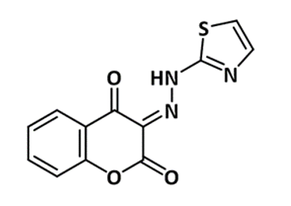

Figure 1. Derivative of coumarin 3-[2-(thiazol-2-yl)hydrazinylidene]chroman-2,4-dione.

