Tweaking 2D-materials structure for pushing the limits of electrochemical energy storage

Aristeidis Bakandritsos
Regional Centre of Advanced Technologies and Materials, CATRIN, Palacký University, Olomouc, Czech Republic; and Nanotechnology Centre, Centre for Energy and Environmental Technologies, VŠB–Technical University of Ostrava, Czech RepublicOrganization
a.bakandritsos@upol.cz ; arisbakan@gmail.com

Functionalization, doping and, in general, tweaking the form of materials (such as in graphene and other 2D materials) is fundamental for harnessing superior properties to enhance their performance in targeted applications.^{[1]} For example, electrochemical energy storage technologies (e.g., supercapacitors and batteries) require advanced functional materials with enhanced charge transport, effective ion storage in confined spaces, integrated redox-active features and stability. Here, the synthesis of tailored graphene derivatives and the self-assembly of 2D aromatic molecular structures into nanowires are presented, and their advantageous properties as electrodes in supercaps and batteries are discussed. By leveraging the reactivity of fluorographene with nucleophiles, in-plane doped and out-of-plane covalently functionalised graphenes are obtained with high functionalization degree and selectivity.^{[2]} The conjugation of charged molecules affords zwitterionic surfaces and π–π electronic interactions, promoting ionic transport and electrochemical activity.^{[3]} Nitrogen superdoping of graphene up to 15 at. % produces conductive, polar and dense graphene electrodes with diamond-like interlayer bonds. Such electrodes deliver ultrahigh volumetric capacitance and energy density, as demonstrated in symmetric full-cells.^{[3]} Graphene acid, a graphene derivative with very high density in carboxylic groups, offers high redox capacity as a Li-ion anode, stemming from its abundant lithiophilic moieties, which are conjugated in a spacer-free manner on the conductive scaffold of graphene.^{[4]} The self-assembly of 2D copper-coordinated carboxylated aromatic molecules into long nanowires leads to ultrahigh lithium diffusivity and superlithiation properties, affording anodes for lithium-ion batteries and lithium-ion capacitors with capacities surpassing 1500 mAh g⁻¹. These properties are not observed if the same system is not in nanowire form. Through such chemical and morphological tweaking of materials, improved properties emerge, laying the groundwork for the development of materials surpassing the limits of their precursors.

References
- Y. Chen, Z. Lai, X. Zhang, Z. Fan, Q. He, C. Tan, H. Zhang, Nat. Rev. Chem. 4 (2020), 243.
- Bakandritsos, A. et al. ACS Nano 11 (2017), 2982–2991.
- A. Bakandritsos, et al. Adv. Funct. Mater. 28 (2018), 1801111.
- Šedajová, V. et al. Energy Environ. Sci. 15 (2022), 740–748.
- Obraztsov, I. et al. Adv. Energy Mater. 12 (2022), 2103010.

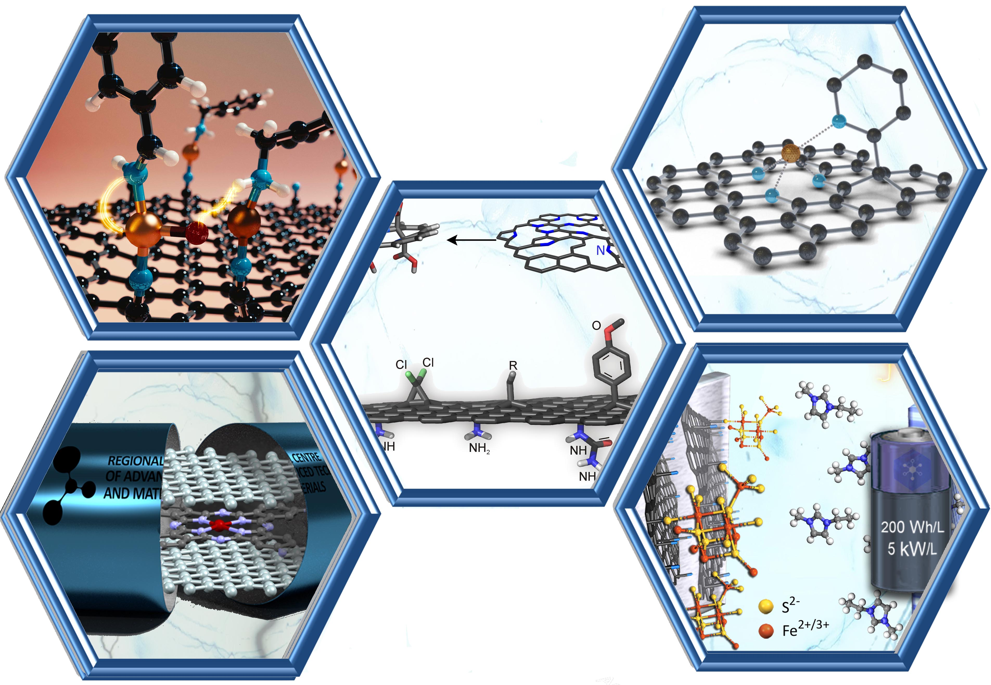
Figure 1: Modified two dimensional materials with improved charge transport, effective ion storage, redox-active features and stability for pushing the limits of electrochemical energy storage.

