Red Blood Cell-Zinc Nanoparticles Nexus: Unravelling the Toxicological Pathways

Valbona Aliko
Erion Sukaj, Marilena Briglia, Xheni Qytyku, Eldores Sula, Erman S. Istifli
University of Tirana, Faculty of Natural Sciences, Department of Biology, Tirana, Albania
valbona.aliko@fshn.edu.al

Abstract

The intersection of red blood cells (RBCs) and zinc nanoparticles (ZnO-NPs) presents a critical frontier in understanding nanoparticle-induced toxicity. Due to their unique morphology and high reactivity, ZnO-NPs hold considerable promise in various biomedical applications. However, the potential adverse effects on erythrocytes remain underexplored. This study delves into the mechanistic pathways through which ZnO-NPs interact with RBCs, focusing on oxidative stress, membrane destabilization, and haemolytic processes as primary toxicological outcomes. Employing advanced imaging, biochemical assays, and computational models, we outline the molecular interactions and resultant cellular impacts, revealing how these nanoparticles may compromise RBC integrity and function. Findings from this research aim to clarify ZnO-NP toxicity mechanisms and contribute to safer nanoparticle designs, particularly in contexts where RBC health is paramount, such as in drug delivery and diagnostic platforms.

References
- Aliko, V., Vasjari, L., Istifli, E.S., Gjonaj, G., Impellitteri, F., Faggio, C., Benedetti, E. Molecular docking analysis and in vivo assessment of zinc oxide nanoparticle toxicity in zebrafish larvae. Aquatic Toxicology, (2024) 107112

Figures

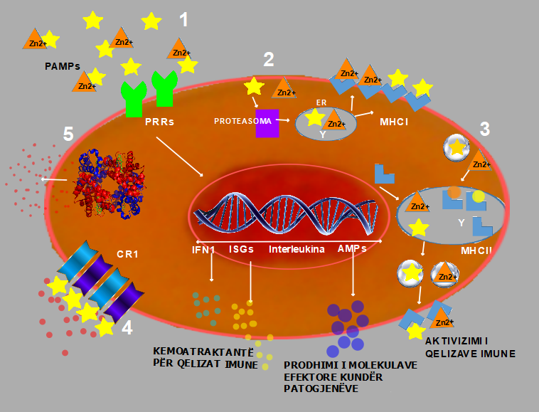

Figure 1: Mechanism of ZnO-NPs induced erythrocytes’ apopotosis

