Learning finite symmetry groups of dynamical systems via equivariance detection

Pablo Calvo-Barlés^{1,2}, Sergio G. Rodrigo^{1,3}, Luis Martín-Moreno^{1,3}
¹ Instituto de Nanociencia y Materiales de Aragón (INMA), CSIC-Universidad de Zaragoza, Zaragoza 50009, Spain
² Departamento de Física de la Materia Condensada, Universidad de Zaragoza, Zaragoza 50009, Spain
³ Departamento de Física Aplicada, Universidad de Zaragoza, Zaragoza 50009, Spain

pcalvo@unizar.es

Symmetries are fundamental to the physical sciences, serving as powerful tools to reduce complexity and reveal the underlying laws governing physical phenomena. In machine learning (ML), and particularly in neural networks (NNs), symmetries play an equally important role. By embedding physical principles as inductive biases—a key idea in physics-informed ML—symmetries can be leveraged to significantly improve model performance. This includes enhancing generalization and increasing robustness against distributional data shifts. The integration of symmetry into ML and NN models can be achieved through various approaches, including the design of
symmetry-preserving architectures and equivariant NNs, the use of symmetry-promoting loss functions, or data augmentation via symmetry transformations.

Discovering the underlying symmetries of a physical system—or a ML task—when they are not explicitly known is both highly valuable and very challenging, especially when only observational data is available. ML provides a robust framework for automatic symmetry discovery due to its capacity to identify patterns from data. Recent advancements have shown that ML models can uncover physical insights from data in unknown or partially known physical systems, including governing equations of dynamical systems, conservation laws, or physically relevant quantities. Of course, various aspects of ML-assisted symmetry discovery have been explored using different strategies. For instance, NNs
have been used for finding coordinate transformations that reveal hidden symmetries, learning transformations that preserve the statistical distribution of data sets, recognizing symmetries from embedding layers and identifying pairs of
symmetric events.

Much of the research in symmetry discovery has concentrated on continuous symmetry groups, particularly the learning of generators associated with Lie groups. However, there has been comparatively less focus on discovering finite symmetry groups, that is, when the set of symmetry transformations is discrete and finite. Some methods for continuous group detection have demonstrated
the capability to identify individual transformations of finite groups, but they do not guarantee the identification of all the elements within the group. In contrast, the discovery of the full finite symmetry group has been addressed in [1], but the method
is limited to invariance detection, that is, identifying transformations in mappings y(x) that act on the input x and leave the output y unchanged.

In this work, we go beyond that limitation and develop a method to detect equivariances, i.e., transformations of the input that transform the output in the same manner. Concretely, we focus on seeking symmetries that are present in equations
describing dynamical systems, where equivariance is particularly relevant (for example, symmetry considerations can be used to simplify the spectral structure of the Koopman operator and calculate more efficiently its eigenmodes). The mathematical function that governs the dynamics of a given system is equivariant under the action of its symmetries. We propose a method to automatically detect the full finite group of linear symmetries in arbitrary nonlinear dynamical systems from collected trajectory data.

References

- Calvo-Barlés, P., Rodrigo, S. G., Sánchez-Burillo, E., & Martín-Moreno, L. (2024). Finding discrete symmetry groups via machine learning. Phys. Rev. E, 110, 045304.
Figures

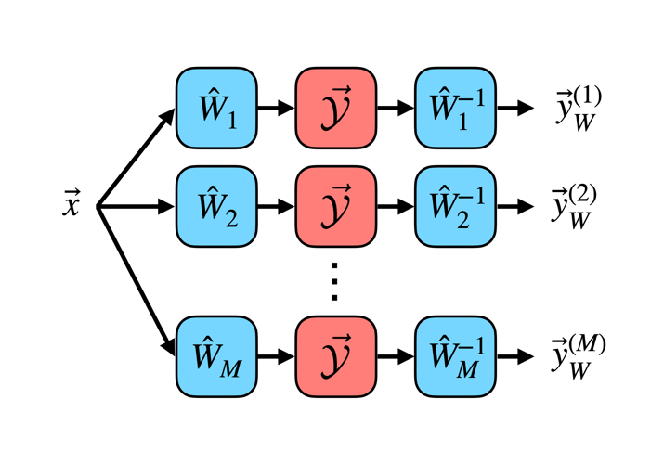
Figure 1. ML-based approach for equivariance group detection: Equivariance Seeker Model (ESM).

