Nanoskiving of edge-exposed graphene nanoribbons with tunable width and inter-edge spacing

Xiaofang Kang¹
Jianwei Gao¹, Buhang Chen^{2,3}, Luzhao Sun^{2,3}, Zhongfan Liu^{2,3}, G. F. Schneider^{1*}
¹Leiden Institute of Chemistry, Leiden University, Einsteinweg 55, 2333CC Leiden, The Netherlands
² Center for Nanochemistry, Beijing Science and Engineering Center for Nanocarbons, Beijing National Laboratory for Molecular Sciences, College of Chemistry and Molecular Engineering, Academy for Advanced Interdisciplinary Studies, Peking University, Beijing, China.
³ Beijing Graphene Institute (BGI), Beijing, China.
x.kang@lic.leidenuniv.nl; g.f.schneider@chem.leidenuniv.nl

Abstract
Graphene nanoribbons (GNRs) exhibit unique electronic properties arising from their one-dimensional confinement and edge effects, rendering them promising for nanoelectronics applications. In this work, we report a novel method to fabricate edge-up, width-tunable GNRs (50-200 nm) by embedding monolayer graphene in resin and precisely controlling the cutting thickness via ultramicrotomy. Notably, the GNR edges are exposed upward while the basal plane remains embedded, enabling subsequent targeted edge engineering. Furthermore, we also controlled the inter-ribbon edge spacing by analyzing the stress distribution during the cutting process and adjusting the blade's angle relative to the graphene. This precise control over GNR width, edge exposure, and inter-edge spacing provides an alternative to lithographic approaches to explore the importance of edge chemistry in nanoribbon sensing.

Figures

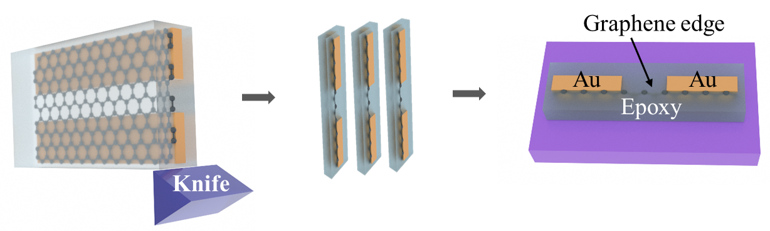

Figure 1: Fabrication of graphene nanoribbon.

